DOCUMENT REFERENCE
Study Report – V.2.0

DATE
4 March 2025

CONTACT INFORMATION

Genesis Analytics (Pty) Ltd South Africa
Office 3, 50 Sixth Road Hyde Park, Johannesburg

www.genesis-analytics.com

AUTHORS
Genesis Analytics

CONTACT PERSON
Saul Johnson
saulj@genesis-analytics.com

Suggested citation: Genesis Analytics, Estimating the extent of mobility and its impact on HIV and TB treatment outcomes in South Africa, 2024.

Table of Contents
Abbreviations 5
Glossary 5
1 | Executive summary 7
2 | Introduction and objectives 10
Mobility and its impact on HIV and TB treatment 10
Objectives 11
Defining mobility 12
3 | Methods 13
Literature review 13
Key informant interviews 14
Secondary data and ecological analysis 14
4 | Results and discussion 15
Objective 1 15
Guidelines related to internal mobility 15
Guidelines related to cross-border mobility 16
Objective 2 17
Internal mobility patterns in South Africa 17
Cross-border mobility patterns in South Africa 18
Profiles of mobility 19
Objective 3 21
Ecological analysis approach 21
Internal mobility 22
Cross-border mobility 24
Overall estimates 27
Mobility and PLHIV and TB 28
5 | Limitations 28
6 | Conclusions and considerations 29
Annex 31
Appendix 1 | References 31
Appendix 2 | Transfer out process 33
Appendix 3 | Detailed secondary data analysis 34
Appendix 4 | Definitions of mobility 40

Figures
Figure 1: UNAIDS HIV targets 10
Figure 2: Understanding how movement, migration and mobility are differentiated 12
Figure 3: Summary of approach 13
Figure 4: Highlighting the focus on transfers in The National Consolidated Guidelines on HIV 15
Figure 5: Mobile population groups in South Africa, categorized by drivers of mobility. 19
Figure 6: Standard transfer out process from facilities and pain points within this process 33
Figure 7: Extent of mobility derived from DHS 2016 survey in South Africa 34
Figure 8: Migration between waves 4 (2014 - 2015) and 5 (2017) by 10-year age bands 36
Figure 9: Directional movement of youth amongst urban and rural regions 37
Figure 10: Percentage distribution of period in-migration by province, 2011 and 2022¹⁷ 38
Figure 11: Percentage distribution of period out-migration by province, 2011 and 2022¹⁷ 38
Tables
Table 1: Search terms for mobile individuals, PLHIV, and people with TB 13
Table 2: Specific questions included in the KII guide 14
Table 3: Key data sources for primary statistics required 14
Table 4: Definitions of the various groups of highly mobile populations 19
Table 5: Summary of method of derivation employed to estimate each parameter in the ecological analysis 22
Table 6: Summary of internal mobility estimates 23
Table 7: Estimating internal mobility amongst PLHIV and people with TB 23
Table 8: Summary of method of derivation employed to estimate each parameter in the ecological analysis 24
Table 9: Summary of cross-border mobility estimates 26
Table 10: Estimating cross-border mobility amongst PLHIV and people with TB 27
Table 11: Overall estimates of mobility amongst PLHIV and people with TB. 28
Table 12: Directional flows for monthly and short-term migration across key corridors in SA 39
Table 13: Ways that different organizations define mobility 40
Boxes
Box 1. 16
Box 2. 28

Abbreviations
Abbrev. | Meaning
AIDS | Acquired immunodeficiency syndrome
ANC | Antenatal care
ART | Antiretroviral therapy
COVID-19 | Coronavirus disease 2019
DHS | Demographic and Health Survey
DOT | Directly Observed Therapy
HDSS | Health and Demographic Surveillance System
HIV | Human immunodeficiency virus
ILO | International Labor Organization
IOM | International Organization for Migration
KII | Key informant interview
LTFU | Loss-to-follow up
MHFUS | Migrant Health Follow-Up Study Wave 01
MMD | Multi-month dispensing
NDOH | National Department of Health
NICD | The National Institute for Communicable Diseases
NIDS | National Income Dynamics Study
PLHIV | People living with HIV
SADC | Southern African Development Community
SAMP | Southern Africa Migration Program
TB | Tuberculosis
UN | United Nations
UNAIDS | Joint United Nations program on HIV/AIDS
WHO | World Health Organization

Glossary
Term | Definition
Mobility | The movement of an individual with the intention of returning home or maintaining strong ties to their home
Migration | The movement of an individual without the intention of returning home
Internal mobility | Movement within national borders where the individual’s home is also located within these borders. In this context, it refers to movement within South Africa.
Cross-border mobility | Movement across national borders, where the individual’s home is situated in neighboring countries (in this context: Zimbabwe, Mozambique, or other sub-Saharan countries.
Person living with HIV | An individual who has been diagnosed with HIV
Person with TB | An individual who is currently infected with tuberculosis

1 | Executive summary

Introduction
South Africa has the world's largest antiretroviral therapy (ART) program while also contending with one of the highest tuberculosis (TB) incidences globally.^{1,2} Adherence to TB treatment, like ART¹, is essential for disease control but often difficult due to its long duration and associated challenges⁴. Mobility, specifically the temporary movement of individuals between places, introduces challenges to HIV and TB treatment adherence, increasing risks of treatment interruption and sub-optimal health outcomes. Mobile individuals face barriers in accessing healthcare, maintaining medication schedules, and achieving treatment adherence, which can impede progress toward epidemic control⁵. Yet, research on the extent and nature of mobility among people living HIV (PLHIV) and people with TB, particularly in South Africa, remains limited. Given the potential impact of mobility on treatment outcomes, it is essential to estimate the scale of PLHIV and people with TB who are mobile. This report describes the results of an exploratory review which aimed to estimate the scale of mobility among PLHIV and people with TB, both within and across the borders of South Africa.

Aims and objectives
We conducted an exploratory review, funded by the Gates Foundation, which aimed to estimate the extent of inter-provincial and regional mobility among PLHIV and people with TB in South Africa. The specific objectives were to:
- Describe the policies, guidelines, and processes related to medicine collection, patient transfer, and linkage to care for mobile populations.
- Characterize mobility types and the population groups affected.
- Estimate the extent of internal and cross-border mobility among PLHIV and people with TB in South Africa.

Definition of mobility
For the purposes of this exploratory review, we considered mobility as both internal and cross-border. We defined internal mobility as the circular migration within country borders, often driven by economic or social factors such as rural-to-urban shifts for employment; and we defined cross-border mobility as the movement of individuals across country borders who maintain connections to their home countries or communities even when moving for extended periods.

Methods
We employed a mixed-methods approach, combining a comprehensive literature review, key informant interviews (KIIs) and secondary data analysis to estimate the number of PLHIV and people with TB who are internally and cross-border mobile using ecological analysis.

Results and discussion

Objective 1 | Policies, guidelines and processes related to care for mobile populations
Through literature reviews and key stakeholder interviews, we described current policies, guidelines and processes related to medicine collection, patient transfer, and linkage to care for mobile populations.
Guidelines for internal mobility: South Africa's 2023 treatment and care guidelines for HIV and TB⁷ include provisions for flexibility and inclusivity to support mobile populations. The guidelines stipulate that ART and TB clinics should issue transfer letters to those patients who seek to continue treatment (including collecting) medication from a different facility. However, the same guidelines allow health workers to provide ART to clients without transfer letters to prevent treatment interruptions. This has contributed to "Silent transfers," where patients switch facilities without informing their parent clinic, thereby contributing to potentially inflated loss-to-follow-up (LTFU) statistics at the parent clinic. Our findings indicate that clinics that deny treatment to patients who do not present with a transfer letter might be disrupting care continuity.
Guidelines for cross-border mobility: Guidelines for internal mobility somewhat apply to individuals who move across borders, however the guidelines are silent on cross-border mobility. Furthermore, cross-border mobility introduces additional challenges to accessing treatment. Migrants often bypass formal transfer processes due to distrust in the South African health system or fear of xenophobia, leading to LTFU. Efforts to address these issues include Zimbabwe’s development of an electronic cross-border referral system to streamline transfers and reduce patient burden. However, implementation faces barriers such as inadequate infrastructure and training needs.

Objective 2 | Mobility types and mobile population groups
Key stakeholder interviews and literature indicated that there are populations who are particularly mobile. These findings are consistent across internal and cross-border mobile individuals. These highly mobile population groups are:
- Economic opportunity related groups: Commercial agriculture, construction, mining, truck drivers, gig economy, domestic workers, gardeners, hospitality, sex workers, street vendors.
- Students: An individual, typically a young person, who is enrolled in a tertiary education institution.
- Undocumented individuals: Individuals who reside within the country without the necessary legal documentation or permits. While this group is categorized separately from the two above, there may be significant overlap meaning these groups are not mutually exclusive.
Our findings indicate that internal mobility patterns were shaped by apartheid policies which entrenched a system of internal circular migration, as individuals moved from rural to urban areas in search of work (most notably to Gauteng province), particularly in sectors like mining and manufacturing.¹⁴ Cross-border mobility is also driven by trade, seasonal work, social visits, and business travel, which occur concurrently with traditional labor migration patterns, as South Africa continuously attracts both skilled and unskilled labor migrants from within the South African Development Community (SADC) region. Popular destinations for cross-border mobility include Mpumalanga which offers employment on farms and game farms, as well as industrial and mining towns along the major cross-country highway, which connects Johannesburg to Maputo in Mozambique.¹⁶

Objective 3 | Estimating the extent of mobility among PLHIV and people with TB
There is almost no existing data on mobility among PLHIV and people with TB, both at a national level and the more granular provincial and/or district level. Given this lack of structured data on mobility, we generated estimates of the number of PLHIV and people with TB who were internally or cross-border mobile by using an ecological analysis.
Internal mobility: We estimate that the total number of PLHIV who are internally mobile is 1.32 million, representing 18% of the total number of PLHIV in South Africa aged 15+ (n = 7,33 million). We estimate that 79,874 internally mobile individuals have TB, which is 21.5% of the total number of people with TB in South Africa (n = 371,900). We used lower, median, and upper bounds to calculate cross-border mobility to account for the variability and uncertainty in data sources and estimates, whereas inter-provincial mobility was based on more consistent and reliable data, which did not require such a range.

Cross-border mobility: The total number of PLHIV who are cross-border mobile using the median bound estimate of 448,107 which is 6.1% of all PLHIV in South Africa aged 15+ (n = 7,33 million). This is compared to 601,935 (8.2%) and 180,581 (2.5%) mobile cross-border migrants living with HIV using the upper and lower bound estimates, respectively. In terms of TB prevalence at the median bound estimate, 20,610 cross-border mobile individuals have TB, making up a small proportion (0.7%) of the total cross-border mobile population of 3,028,068.
Overall, approximately 24% of PLHIV (1.77 million) and people with TB (107,559) may be mobile (internally or cross-border). The reason that TB is higher among internal vs. cross-border populations is not yet understood and beyond the scope of this research. Furthermore, while mobility is a known risk factor for disengagement in HIV care, the achievement of the 95’s among this group is not known and is beyond the scope of this research.

Limitations
Research on mobility often emphasizes migration, but this approach inadequately captures temporary mobility, which is complex and challenging to investigate due to limited and inconsistent data, especially in Sub-Saharan Africa. Furthermore, due to scarce national-level data, we relied on diverse sources and educated assumptions, acknowledging that some were outdated, limited in power, or lacked generalizability, but they provided the best available estimates. These data sources varied in defining mobility and were not exhaustive, with some, like the International Organization for Migration (IOM) dataset, excluding critical border crossings and undocumented movements, leading to an incomplete picture of temporary mobility. This study focused on working-age individuals, excluding the potential impact of adult mobility on their children's treatment adherence.

Conclusion
The exploratory review suggests that about a quarter of PLHIV and TB patients in South Africa are mobile, facing difficulties in accessing continuous and uninterrupted access to their HIV and TB medications as a result of their mobility. The forthcoming government initiatives like the centralized medical record system may mitigate some challenges by providing seamless access to medication and patient files without the need for formal transfer letters and processes, but its potential for cross-border transfers remains limited. In the interim, improvements can be made through increased flexibility in transfer mechanisms, better patient education, mobile treatment distribution, digitization of patient records, simplification and wider usage of transfer letters, and the creation of mobile-individual transfer cards. Additionally, more research on mobile patient needs and safe access for undocumented individuals can further enhance their treatment outcomes. These measures could substantially improve treatment adherence and continuity for these highly mobile, vulnerable groups as South Africa trudges along towards the UNAIDS 95-95-95 targets by 2025. Quantifying achievement along the 95’s among mobile populations is a key next step and would provide a benchmark against which effectiveness of interventions can be monitored.

2 | Introduction and objectives
South Africa has the largest antiretroviral therapy (ART) program in the world; providing ART to almost 5.7 million out of the 7.33 people living with HIV (PLHIV).¹ Access to ART is a crucial component of an effective HIV management program, and adherence to ART is equally essential for achieving and maintaining viral suppression. Adherence to ART is key to reaching UNAIDS' 95-95-95 targets, which aim to ensure that 95% of PLHIV are aware of their status, 95% of those who know their status are on ART, and 95% of those on ART achieve viral suppression. In 2023, 95% of PLHIV in South Africa were aware of their status, but only 77% of them were on ART. Of those on ART, 92% had achieved viral suppression.¹
South Africa consistently ranks among the highest countries for tuberculosis (TB) incidence. In 2023, the World Health Organization (WHO) reported an estimated TB incidence of 427 cases per 100,000 people in the country.² Additionally, South Africa ranks third globally for HIV-related TB cases, with up to 60% of PLHIV co-infected with TB.³ Failure to fully adhere to treatment has been identified as the most critical issue in controlling TB and a significant barrier to eradicating the disease.⁴ Adherence to TB treatment can be difficult because it typically lasts six months or more, involves multiple medications, and can have uncomfortable side effects.
Mobility poses a risk to the engagement in care for HIV and TB patients. Mobile individuals are less likely to utilize preventive services, access care easily, and adhere to treatment.⁵ Consequently, they are more likely to discontinue treatment resulting in adverse outcomes, and mobile PLHIV are less likely to achieve viral suppression compared to those who are not mobile.⁵
Despite the critical impact of mobility, limited research exists on the extent of internal and cross-border mobility among PLHIV and people with TB in South Africa and the broader region. Understanding the magnitude of mobility among these groups will allow a better estimation of potential impact on epidemic control if we achieve better engagement in care among these mobile populations. We conducted an exploratory review to estimate the extent of this mobility and assess its potential influence on treatment adherence and outcomes. By examining South Africa's health system within the context of sub-Saharan Africa, this review aims to inform the scope, scale, and potential focus of future investments targeting mobile populations across the region.

Mobility and its impact on HIV and TB treatment
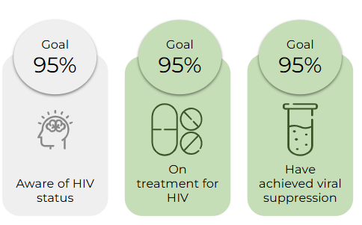
Mobile populations face unique challenges that negatively contribute to their health outcomes, particularly in the continuum of HIV and TB care. Not only do mobile populations have a higher prevalence of HIV and TB, but they also have poorer health outcomes.⁶ In the context of HIV, this impedes the achievement of the UNAIDS 95-95-95 goals, especially the second 95 target (ensuring 95% of diagnosed individuals are on treatment) and the third 95 target (achieving viral suppression in 95% of treated individuals). Similarly, in TB care, mobility threatens comparable priorities within the TB care cascade, such as initiating treatment for those diagnosed and ensuring successful treatment outcomes.

Figure 1: UNAIDS HIV targets
For both people with TB and PLHIV, programs want to ensure individuals initiate and remain on treatment. In the context of HIV, this is referred to as the second 95 target, however, also relates to the third 95 target as remaining treatment is essential for viral suppression. Mobility often interferes with these goals as it disrupts medication routines, leading to missed clinic visits, delayed medication refills, disrupted treatment schedules, and compromised patient outcomes. Temporary travel can result in patients missing appointments or losing access to healthcare services.⁷ Demonstrating this, one study has found that in high-mobility regions, such as peri-urban areas in South Africa or cross-border regions like the Kenya-Uganda border, mobile individuals experience up to a 47% reduction in viral suppression rates due to these disruptions.⁸
For TB, mobility introduces similar risks to that of HIV, but slightly different consequences. Mobile individuals often face challenges in engaging with adherence support programs, such as Directly Observed Therapy (DOT), due to the difficulty of consistently taking their medication while frequently changing locations. Incomplete or inconsistent treatment fosters the development of drug-resistant TB strains, which are significantly more challenging and expensive to treat. These regimens are often prolonged and associated with severe side effects, imposing heavy burdens. Moreover, drug-resistant TB can be transmitted to others, compounding public health challenges in already high-burden areas.⁹
An unpublished study conducted in PEPFAR-supported districts across South Africa by Genesis Analytics (2024) in collaboration with Project Last Mile found that 12% of PLHIV who interrupted their treatment for 28 days or more cited movement as the primary reason for their most recent treatment interruption, as they frequently relocate between various places and countries. This was the most frequently selected reason.
In South Africa, multi-month dispensing (MMD) programs have been introduced which act as one solution for PLHIV who are mobile. However, this is not the case for TB, as its management and follow-up are more complex. While MMD could be explored for specific TB patient groups, it is not universally applicable. MMD allows for longer durations between clinic visits which could support mobile individuals to collect their medication, assuming they are able to plan their trips accordingly. However, we know mobility can be economically motivated or unplanned, which means that movement patterns, often dictated by employers, are unpredictable and hard to schedule. Furthermore, decanting individuals from standard clinic visits to MMD programs has been slow and may not be a viable solution for individuals who travel for longer periods of the year (6 months or more). These individuals may need to transfer between clinics to ensure treatment continuation.
Mobility represents a "low-hanging fruit" that may be addressed more readily than issues which required significant effort and multi-sectoral action (such as alcohol abuse and gender-based violence). Therefore, given the significant impact of mobility on treatment outcomes, it is essential to quantify the number of PLHIV and people with TB who are mobile. Understanding the scale and patterns of mobility, both internally within South Africa and cross-border, can inform tailored interventions to improve health outcomes.

Objectives
We conducted an exploratory review, funded by the Gates Foundation, which aimed to estimate the extent of inter-provincial and regional mobility among people living with HIV (PLHIV) and people with TB in South Africa. The specific objectives of the study were to:
- Describe national policies, guidelines, and processes used for medicine collection, patient transfer, and linkage to care across different healthcare facilities as they relate to mobile populations in South Africa and sub-Saharan Africa.
- Characterize the types of mobility and population groups.
- Estimate the extent of internal and cross-border mobility among PLHIV and people with TB in South Africa.
This report provides a summary of the methodology and principal findings uncovered during this exploratory review.

Defining mobility
While exploring the existing definitions of mobility, we encountered many ways of defining the concept. A full summary of terms used by key organizations has been provided in Appendix 4. Given that research aims vary—from public health studies focused on high-risk populations to economic analyses of labor migration—the concept of mobility is frequently adapted to suit the context, leading to broad and flexible definitions and interpretations.
While reconciling definitions across sources is beyond the scope of this project, we defined mobility (see Figure 2) as the movement of an individual with the intention of returning home or maintaining strong ties to their home, distinguishing it from migration. For the purposes of this report, we identified two types of mobility:
- Internal mobility, which refers to movement within national borders which does not result in a change of residence, where the individual’s home is also located within these borders (in this context, within South Africa).¹⁰ This kind of movement is often driven by social, economic, or political factors. In South Africa, internal mobility is characterized by high rates of movement from rural to urban areas, in search of employment. This pattern has its roots in the apartheid-era legacy of circular movements between rural and urban areas, where people would relocate temporarily for work while maintaining ties to their rural homes.⁶
- Cross-border mobility, which involves movement across national borders, with the individual’s home situated in neighboring countries such as Zimbabwe, Mozambique, or other sub-Saharan countries. ¹¹ Individuals may stay away from their household or community for extended periods but maintain strong ties, such as returning home periodically or retaining membership in a household. In the context of households, cross-border mobile individuals live elsewhere but still consider themselves part of their household.

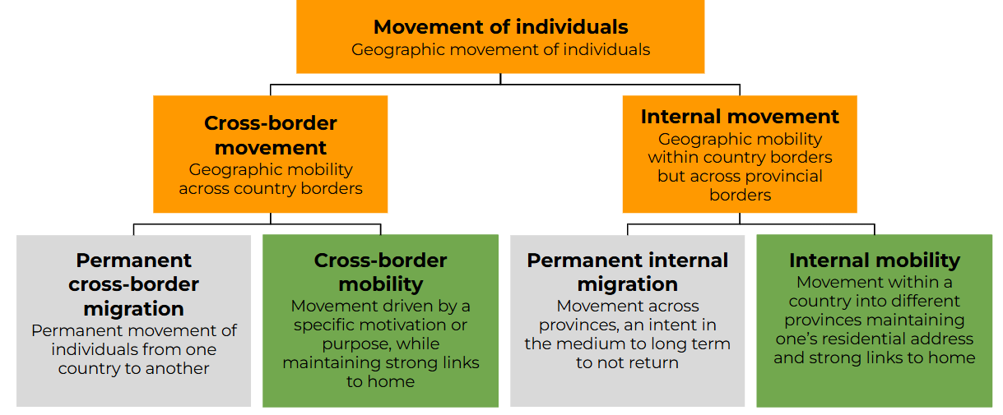

Figure 2: Understanding how movement, migration and mobility are differentiated

3 | Methods
We have employed a mixed-methods approach, combining a comprehensive literature review, key informant interviews (KIIs) and a secondary data analysis to estimate the number of PLHIV and people with TB who are mobile and the impact of mobility on HIV and TB treatment adherence using ecological analysis. We conducted the literature review first, then KIIs, and finally the secondary data analysis. This mixed methods approach allowed us to develop several iterations for each method as data from the literature review, KIIs, and secondary data analysis was triangulated and synthesized. Our sequence is illustrated in the Figure 3 below:

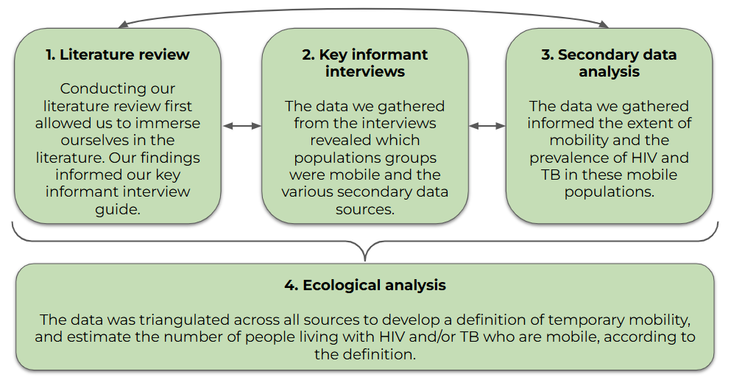

Figure 3: Summary of approach

Literature review
The literature review for this study was undertaken to identify population groups characterized by mobility and to gain a deeper understanding of cross-border and internal movement patterns. In addition to examining mobility, the review also explored relevant policies and guidelines to contextualize mobility within the HIV and TB treatment cascades. The literature review provided us with relevant estimates used in our ecological analysis to quantify the number of PLHIV and people with TB who are mobile.
Through this review, we identified key mobile population groups, which were subsequently validated and expanded upon during discussions with key informants. Details of the search terms used in the literature review are provided in Table 1, and the complete bibliography is available in the reference list in Appendix 1.

Table 1: Search terms for mobile individuals, PLHIV, and people with TB
Term | Search terms (non-exhaustive, snowball search terms utilized)
Cross-border mobility | Mobile individual  Temporary migration/migrants  Circular migration/migrants  Seasonal migration  Internal migration
Internal mobility
PLHIV | A person who has been diagnosed with HIV  HIV-positive individuals
People with TB | A person who has been diagnosed with TB  TB patients

Key informant interviews
We conducted twelve KIIs with representatives from various organizations. These discussions confirmed the groups highlighted in the literature and prompted informants to identify additional groups with similar mobility characteristics. Furthermore, these interviews expanded our understanding of the characteristics, movement patterns, and health needs of mobile populations and examined health system processes related to continuity of care for these individuals. These KIIs helped identify mobile population groups which informed our secondary data analysis.
Informed by early learnings from the literature review, our KII guide was structured to further explore specific areas as illustrated in Table 2 below:

Table 2: Specific questions included in the KII guide
Question
1 | Who constitutes mobile populations?
2 | What are common movement patterns among these populations?
3 | How do current health system processes support mobile individuals?
4 | To what extent is loss-to-follow-up (LTFU) caused by mobility issues?
5 | Why does mobility cause LTFU?
6 | Would addressing mobility-related LTFU significantly impact overall LTFU rates?
7 | Are health programs currently addressing mobility among PLHIV and TB patients?
8 | Are there any mechanisms to track mobility among PLHIV or TB patients?
9 | What solutions are being or could be implemented to address mobility-related LTFU?

Secondary data and ecological analysis
Our analysis aimed to access several datasets for research purposes, each offering valuable insights into diverse aspects of mobile populations and their health status. It is worth noting that there is no complete dataset in South Africa that tracks internal or cross-border mobility that we are aware of. Furthermore, it is difficult to separate both permanent versus temporary, and cross-border versus internal migration. However, triangulation across multiple data sources gives us an estimate, albeit with limitations. We have described the key data sources that were used in Table 3 below.

Table 3: Key data sources for primary statistics required
Population size estimates | Mobility | HIV prevalence | TB prevalence
- Statistics South Africa Census and Labor Force Survey data  - International Labor Organization (ILO) data  - South Africa Ministry of Home Affairs data  - Fairwork data | - Demographic Health Survey South Africa (DHS: 2016)  - IOM Flow monitoring reports (2023)  - South African Migration Program (SAMP) survey | - UNAIDS South Africa HIV and AIDS Estimates  - Journal of the Sexually Transmitted Disease Association data  - Higher Education HIV/AIDS program data | - NICD TB Prevalence Survey data

These datasets collectively present a rich tapestry of valuable information on population movements and health implications. We developed our methods for the ecological analysis, detailed on page 21, using insights from the literature review, KIIs, and secondary data analysis.

4 | Results and discussion

Objective 1
This section describes the national policies, guidelines, and processes used for medicine collection, patient transfer, and linkage to care across different healthcare facilities as they relate to mobile populations in South Africa and sub-Saharan Africa.
We do this by first describing guidelines that are relevant to internal mobility. This discussion draws the distinction of guidelines and policies that have been developed, and the observed limitations with their implementation. Furthermore, we discuss the integration of digital health solutions to address challenges with treatment continuity for internally mobile populations.
Subsequently, our discussion highlights existing guidelines related to cross-border mobility. While recognizing that challenges associated with internal mobility often extend to cross-border scenarios, we emphasize the unique difficulties faced by cross-border individuals, such as xenophobia within South Africa's healthcare system.

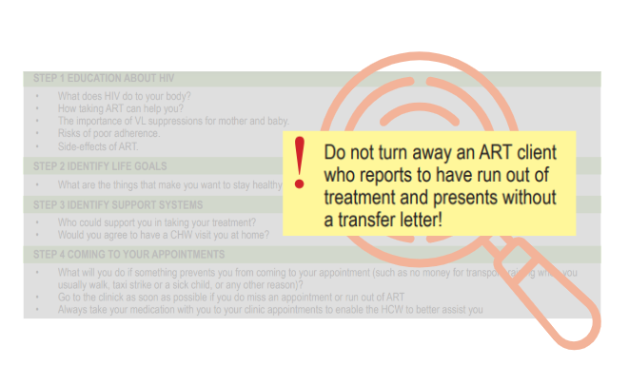
Guidelines related to internal mobility

Figure 4: Highlighting the focus on transfers in The National Consolidated Guidelines on HIV

South Africa's 2023 national guidelines for HIV and TB care emphasize flexibility and inclusivity to support mobile populations. For example, guidelines state that clinics are required to issue transfer letters when patients request them to collect medication from a different facility, allowing for continuity in treatment across locations. As highlighted in Figure 4, the national guidelines make provisions for ART to still receive drug re-fills even without transfer letters to prevent treatment interruptions.⁷
Although guidelines and de facto processes aim to facilitate continuity of care for mobile populations, challenges arise in their implementation, as revealed by some of our KIIs. These challenges create pain points for patients, nudging individuals to drop out of care. This was consistent with the findings of a study in rural KwaZulu-Natal which found that participants reported having difficulties obtaining transfer letters.¹² Our findings highlighted various pain points in the transferring process (see Appendix 2 for a comprehensive demonstration of these), which included nurses telling patients to fill-in the transfer letters themselves. Additionally, there were reports that some clinics were denying treatment to patients who reported without transfer letters, directly contravening the guidelines.
Mobility and maternal health
For pregnant women on ART, the guidelines recommend maintaining their current regimen during the transition to antenatal care (ANC) services and documenting their status as a transfer-out, ensuring continuity of care. These measures aim to reduce treatment lapses and associated risks, especially during critical periods such as pregnancy and postpartum, when mobility is often unavoidable.¹³
However, postpartum women living with HIV are particularly vulnerable to negative outcomes when transferring between facilities. Transitions from integrated antenatal/HIV care to general HIV services often disrupt continuity. Studies highlight how barriers such as insufficient information about transfer processes, fear of stigma, and inconsistent management of silent transfers undermine care. Mobility for reasons such as geographic relocation compounds these challenges. Effective management requires robust health system mechanisms to track transfers, provide clear patient guidance, and ensure health workers facilitate seamless transitions without stigma or judgement.¹³

Box 1.
“Silent transfers," where patients switch facilities without informing their parent clinic, contribute to inaccurate and often inflated LTFU statistics. These inaccuracies in LTFU numbers have been previously reported, with one study suggesting that one-third to two-thirds of patients labeled as LTFU may have silently transferred to other clinics in South Africa.¹³
To improve treatment adherence for patients with chronic conditions in South Africa’s healthcare system, the South African Department of Health initiated the Central Chronic Medicines Dispensing and Distribution (CCMDD) program to combat medication adherence barriers such as overcrowded facilities and overburdened pharmacy staff. This program has impacted the care of chronic illnesses like HIV and TB, particularly for mobile populations. By enabling stable chronic patients to collect their repeat prescriptions from external pick-up points closer to their homes or workplaces, CCMDD not only eases the strain on healthcare facilities but also boosts system efficiency. Moreover, for mobile populations, this improved access and convenience greatly enhanced medication adherence, leading to improved patient outcomes for those with chronic conditions such as HIV and TB.
However, interoperability of patient information remains a significant challenge for patients that not only transfer out of their parent health facilities but also those that pick medication from the CCMDD points. Previous studies have indicated that South Africa’s health system remains highly fragmented with multiple health information systems, inhibiting healthcare delivery and access to integrated health data.¹⁴ South Africa’s 2019-2024 National Digital Health Strategy seeks to address this challenge but focusing on the roll-out of Electronic Health Records (EHRs).¹⁵ Though private hospitals such as Netcare have begun implementation of an integrated EHR systems (CareOn)¹⁶, the public health sector that caters for over 80% of the country’s population¹⁷ still heavily relies on manual and paper-based records systems.

Guidelines related to cross-border mobility
While guidelines for internal mobility often apply to individuals who move across borders, the South African guidelines are silent on processes necessary for cross-border mobile individuals. Furthermore, being cross-border mobile introduces additional challenges. Our findings indicate that cross-border mobile individuals often bypass formal transfer processes due to reported distrust in the South African health system and/or fear of xenophobia. This lack of traceability directly contributes to LTFU numbers in the parent clinics. Key informant discussions highlighted that mobility following an HIV or TB diagnosis, particularly among those recently diagnosed with TB, is common. For example, Zimbabwean migrants often return to their home countries for treatment, further exacerbating LTFU as they navigate care transitions without formal referrals.
One key informant highlighted that Zimbabwe has begun developing an electronic cross-border referral system to improve continuity of care for cross-border mobile patients. This digital system aims to streamline the referral process by eliminating the need for patients to carry physical letters, reducing their responsibility in managing treatment transfers. While the system is not yet operational, it is expected to have a significant impact once implemented. However, the informant noted challenges associated with its rollout, including the need for substantial investment in training, equipment, and reliable internet access.

Objective 2
This section characterizes the mobility types and population groups who are most affected.
We first discuss the internal mobility patterns within South Africa, highlighting the significance of the country’s history in the movement patterns, which has impacted the search for economic employment in urban areas.
We then discuss the cross-border mobility patterns within Southern Africa, concentrating on short-term mobility between South African Development Community (SADC) countries and South Africa, which is largely driven by economic opportunities, political instability, or environmental risks.
We then identify and discuss the population groups which are considered highly mobile in South Africa. They either fall into the economic opportunity related category or are students or undocumented individuals.

Internal mobility patterns in South Africa
Apartheid policies in South Africa established a rigid system of spatial segregation, notably through the creation of "homelands" where African communities were forcibly relocated to rural areas. This system generated a pattern of circular migration, with individuals primarily moving from rural to urban areas in search of work, especially in industrial sectors such as mining and manufacturing. As urbanization was restricted and opportunities in rural homelands remained scarce, the movement of labor became a means of survival, perpetuating cycles of poverty. These migration patterns were shaped by government policies that promoted labor migration, with men often working in urban areas while their families remained in rural, economically disadvantaged regions.¹⁴ This historical context of forced displacement and labor migration laid the foundation for current internal movement trends in South Africa.
Today, internal movement patterns remain heavily influenced by economic opportunities, particularly in regions like Gauteng, which attracts up to 60% of unemployed temporary migrants seeking work.¹⁸ Other common destinations include Mpumalanga, where employment in agriculture and game farms is prevalent, and towns along major highways, such as those in the industrial and mining sectors. Seasonal labor migration is also significant, with cyclical movement observed between the Western Cape and Eastern and Northern Cape during harvest periods, particularly for the wine industry.¹⁹ This continued movement reflects a pattern of labor migration that, while no longer state-enforced, is deeply rooted in the spatial and economic divides created during the apartheid era. These migration trends underscore the enduring legacy of apartheid-era spatial segregation, which continues to shape mobility patterns today.

Cross-border mobility patterns in South Africa
Migration to Southern Africa is largely propelled by the quest for economic opportunities, political instability, and a growing prevalence of environmental risks. South Africa, with its status as the most industrialized economy in the Southern African Development Community (SADC) region, a robust mining sector, and considerable educational opportunities, continuously attracts both skilled and unskilled labor migrants from within the SADC region and elsewhere.²⁰
The 2023 IOM Flow Monitoring Registry data reveals intricate short-term mobility patterns, defined as less than six months, between South African Development Community (SADC) countries and South Africa. These movements predominantly occur along both primary and secondary geographical pathways. Notably, significant corridors such as Beitbridge (Zimbabwe – South Africa) and Ressano Garcia (Mozambique – South Africa) record a substantial proportion of short-term mobility. Other primary corridors, like those connecting Malawi (Mwanza) to Mozambique (Zobue), also exhibit higher short-term movement rates, compared to other motivations for crossing borders. Secondary routes, including the connections between Zimbabwe and Botswana (Plumtree), Zimbabwe (Chirundu) and Zambia, and Zimbabwe (Mutare) and Mozambique (Manica), also exhibit a high degree of short-term mobility.
A general observation is the more prominent occurrence of short-term movements from South Africa to its neighboring countries, yielding asymmetric flows. For instance, the Beitbridge corridor records more short-term flows from South Africa to Zimbabwe than vice versa. Similarly, at Ressano Garcia, more short-term movements occur from Mozambique to South Africa than in the reverse direction. On average, cross-border short-term mobility makes up a significant portion of all movements.
Such short-term movements mainly consist of activities such as short-term trade, seasonal work, social visits, and business travel. They occur alongside traditional labor migration patterns, especially in corridors such as Beitbridge and Ressano Garcia. Noteworthy employment destinations include Mpumalanga, known for farm and game farm employment opportunities, and towns along the N4 highway, which links Johannesburg to Maputo in Mozambique and houses several industrial and mining operations.²¹
The prominence of circular and short-term mobility necessitates its unique recognition within cross-border migration governance frameworks. This fact speaks to the dynamic nature of cross-border movements in the region and highlights the need for adaptable and responsive policies that effectively manage this mobility, and its potential impact on other factors of individuals’ lives, such as access to medication and corresponding adherence.

Profiles of mobility
Our review identified several key groups of mobile individuals in sub-Saharan Africa. Through the literature review and key informant discussions, we identified specific populations which exhibited higher levels of mobility compared to the general population. These are organized into two distinct categories (see Figure 5 below); economic opportunity related mobility and students. The sub-categories have been defined in Table 4, below.
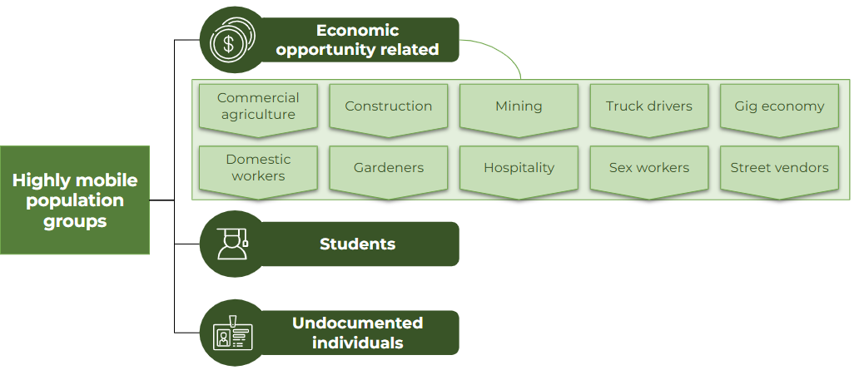

Figure 5: Mobile population groups in South Africa, categorized by drivers of mobility.

Table 4: Definitions of the various groups of highly mobile populations
Category | Sub-category | Description of group
Economic opportunity related | Commercial agriculture | An individual employed in the agricultural sector who performs manual labor tasks on large-scale farms or agricultural businesses.
Economic opportunity related | Construction | Laborers who perform physical tasks on construction sites, including building, repairing, and maintaining structures like buildings, roads, and bridges, often using specialized tools and machinery.
Economic opportunity related | Mining | Laborers who extract minerals, resources, or other valuable materials from underground or surface mines often perform physically demanding and hazardous tasks.
Economic opportunity related | Truck drivers | Professionals who operate large vehicles to transport goods and materials over long or short distances, ensuring timely delivery while following safety and road regulations.
Economic opportunity related | Gig economy | An individual who operates a personal or rented vehicle to perform on-demand transportation or delivery services, typically through digital platforms.
Economic opportunity related | Domestic workers | Individuals (often women) employed to perform household tasks such as cleaning, cooking, laundry, childcare, and other personal services within a private home.
Economic opportunity related | Gardeners | An individual employed (often informally) to maintain and cultivate outdoor spaces for private homes or commercial properties.
Economic opportunity related | Hospitality | Individuals employed in the service industry to provide services related to lodging, food, beverages, and event planning, including roles such as hotel staff, restaurant servers, chefs, bartenders, housekeepers, and event coordinators.
Economic opportunity related | Sex workers | Individuals who engage in consensual sexual activities or provide related services in exchange for money or goods.
Economic opportunity related | Street vendors | Individuals who sell goods or services directly to customers in public spaces, such as streets, markets, or sidewalks, typically operate with minimal overhead and without a permanent storefront.
Students |  | A student is an individual, typically a young person, who is enrolled in a tertiary education institution such as a university, college, or vocational school, pursuing academic studies or specialized training to gain knowledge and skills in a particular field.
Undocumented individuals |  | Individuals who reside within the country without the necessary legal documentation or permits. This can include those who enter the country illegally, those who overstay their visas, or individuals who are born to non-South African parents without obtaining legal status. For the purpose of this review, our analysis focuses on the former category.

1. Economic opportunity related mobility
Through our key informant discussions and literature review, we identified several groups commonly engaged in mobility for work, including commercial farmworkers, constructions workers, miners, truck drivers, domestic workers, gardeners, hospitality workers, sex workers, fishermen, game farm workers, street vendors, and drivers. Some individuals from rural areas who have moved around for work often like to maintain their rural family base, while working in industrial provinces like Gauteng¹⁸. Gauteng is a significant destination, drawing up to 60% of unemployed cross-border mobile individuals seeking work.¹⁸
One key informant discussed the cyclical movement of individuals, primarily driven by seasonal labor demands. Temporary labor migration is a significant phenomenon in South Africa; in 2008, the National Income Dynamics Study (NIDS) found that 12.6% of African households and 21.8% of rural African households included at least one temporary labor migrant²². Much of this movement occurs between the Western Cape and the Eastern and Northern Cape, particularly during harvest periods for wineries. These patterns of temporary migration, especially in rural areas, highlight the challenges faced by mobile individuals in accessing continuous healthcare services. The key informant emphasized the potential benefits of avoiding HIV LTFU by collective action by employer groups, such as farmers, to organize access to HIV treatment for workers while they are away from their primary residences.
One key informant discussed a model which they created called the Mobility Model. It aims to categorize the various types of men that move around specifically regarding mine work. They identify four types of men who commonly work in these types of contexts: (1) classical migrants, (2) distant/transitional migrants, (3) locals and (4) distant locals.
- Classical Migrants: Older, lower-educated, blue-collar men from labor-sending areas who work temporarily in mining towns, returning home yearly. They are more susceptible to HIV due to isolation, multiple sexual partners, and lack of family presence. They often work long shifts and live in poor conditions with little care or support.
- Distant/Transitional Migrants: Similar to classical migrants but bring their families with them. They seek more stable living conditions near schools and other amenities. They are potentially less vulnerable to HIV due to family presence.
- Locals: Residents who live permanently near the mine, focusing on settling down, buying homes, and establishing strong social networks.
- Distant Locals: Locals who live too far to commute daily to the mine, often staying in temporary shacks near the mine during work periods, while their families live further away.

2. Students
Including students as a mobile population is essential due to the unique challenges they face with frequent, temporary relocations, often for education or employment. In South Africa, this trend is especially significant as many young people move between provinces to access educational institutions or enter the job market, as noted by a key informant. These students typically maintain their primary residences in their home regions while residing temporarily elsewhere, placing them in a category of temporary mobility.
Data from Demographic and Health Surveillance sites in areas like Hlabisa (KwaZulu-Natal) and Agincourt (Mpumalanga) confirm that educational and employment pursuits drive youth mobility¹¹, yet research on this remains limited.

3. Undocumented individuals
Undocumented individuals are a critical vulnerable population to include in our study on mobility. Many of these individuals come from neighboring countries, often driven by economic hardship to seek employment in South Africa. However, their presence is frequently met with hostility, as they are perceived by some as competing for scarce jobs.
This societal hostility extends to their experiences within the healthcare system, where mistrust and barriers to access further marginalize them and their access to care. As identified by key informants, healthcare is a significant driver of mobility for undocumented individuals, as they frequently return to their home countries for treatment, particularly for TB, where they may feel better supported by their own healthcare systems and communities. It is assumed that these individuals return to their home countries at least once a year, underscoring the cyclical nature of their movement.
We note that undocumented individuals are not a mutually exclusive group but rather intersect with other mobile populations (for example, an undocumented gardener or domestic worker). This overlap presents a limitation in our research, as it makes it challenging to generate precise estimates for each group, potentially leading to some degree of double counting. However, recognizing these intersections is crucial for understanding the broader mobility patterns and healthcare challenges faced by these populations.

Objective 3
In this section, we estimate the extent of internal and cross-border mobility among PLHIV and people with TB in South Africa.
We begin by outlining the steps undertaken in our ecological analysis, including the identification of highly mobile groups through a comprehensive literature review and key informant interviews.
Next, we detail our approach to estimating internal mobility for both highly mobile population groups and the general population, alongside their respective HIV and TB prevalence rates. Based on our computations, we estimate that 1,318,956 PLHIV and 79,874 people with TB are internally mobile in South Africa.
Similarly, we discuss and estimate cross-border mobility amongst PLHIV and people with TB for our highly mobile population groups and the general population. Based on our computations, we estimate that 448,107 PLHIV and 20,610 people with TB move across borders of South Africa.

The purpose of quantifying mobility among PLHIV and people with TB in South Africa is to provide a clearer understanding of the extent and patterns of internal and cross-border movement within these populations. These insights can inform future resource allocation and investment decisions to better address the needs of this population.

Ecological analysis approach
In generating size estimates of internal and cross-border mobility among PLHIV and TB populations, we first conducted a literature review to identify existing research on this topic. Additionally, we consulted key stakeholders to determine if such analyses had been previously undertaken. We noted an overwhelming scarcity of recent and objective data on temporary mobility. As discussed in Objective 1, we engaged with key stakeholders to identify and pinpoint highly mobile populations. Subsequently, we estimated the population sizes of these highly mobile groups, as well as the general population. Utilizing smaller, population-specific studies, we determined three parameters for each of these groups: 1) the proportion of migrants in South Africa; 2) the extent of mobility; and 3) HIV prevalence and TB point prevalence.
These parameters were then used to calculate the number of PLHIV and people with TB who are mobile. There are differences in the methods of derivation for internal and cross-border mobility, and these differences have been described in their respective sections.
While it appears that economically driven mobility is the most significant driver of mobility in South Africa¹⁸, we understand that there may be other populations which may not be included here as they have not been identified as high-risk vulnerable groups in the HIV and TB sectors. However, their mobility may put them at risk for poor adherence. Therefore, we have also estimated internal mobility for the general population by age group using a similar approach applied above.
Throughout this process, we compiled data from various sources and time periods, prioritizing the most recent data available. Table 4 below summarizes the parameters estimated and the methods used for deriving an estimate of the number of internal or cross-border mobile people living with HIV and/or TB.

Internal mobility
The analysis of internal mobility focused on estimating the extent of mobility amongst two groups: (1) highly mobile population group, and (2) the general population. The parameter estimated and method of derivation is detailed in Table 5 below.

Table 5: Summary of method of derivation employed to estimate each parameter in the ecological analysis
Code | Parameter | Method of derivation
N | Total population size | Highly mobile population group  - Estimate derived from the most recent source available, often white papers, news articles or other reports from that employment sector.  General population  - The population sizes for the general population by age group and sex were also obtained from STATS SA mid-year population estimates (2024). We only included working age populations. We also subtracted the number of individuals who were already included in the analysis of economic opportunity-related mobility and students.
Pr | Proportion of cross-border migrants | Highly mobile population group:  - Estimate derived from the most recent data source available, either IOM, census data, or other reports from that employment sector.  General population  - Estimate derived from STATS SA Migration profile report (2023)
nr | Number of cross-border migrants | N*Pr
ni | Number of South African citizens | N - nr
Pim | Prevalence of internal mobility (among South African citizens) | Highly mobile population group:  - Estimates derived from smaller studies specific to the population group.  General population  - Estimates inferred from the DHS (2016) dataset by age and gender (see Appendix 3)
nim | Number of South African citizens who are internally mobile | ni x pim
PrevHIV | HIV prevalence | Estimates derived from UNAIDS, or smaller population-specific studies.
PPrevTB | TB Prevalence | Estimates derived from surveys conducted by the National Institute of Communicable Diseases or smaller population-specific studies.
CoPrev | Prevalence of HIV among people with TB (co-infection) | Estimates derived from WHO²³
nimHIV | Number of internally mobile South African PLHIV | nim x PrevHIV
nimTB | Number of internally mobile South African people with TB | nim x PPrevTB
nimHIVTB | Number of internally mobile South African people with TB that are co-infected with HIV | nimTB X CoPrev

To estimate the prevalence of internal mobility among South African citizens (Pim), we analysed the DHS 2016 survey conducted in South Africa. Respondents were asked about the frequency and duration of their absences from home in the past 12 months. Mobile individuals were defined as those that spend a night away from home either 12 times or more during the year or leave home at least once a year for a period of one month or more.¹⁰
Our estimate of the prevalence of internal mobility (Pim) ranged from 19% to 100% by sector (for example, 100% of truck drivers are considered mobile), showing the variability of mobility amongst groups. For further details on the findings, please refer to the full analysis included in the annex.
Table 6 summarizes the key estimates for internal mobility. Based on our findings, we estimate that there are approximately 6.75 million South African citizens who exhibit internal mobility; 2.78 million from the economic opportunity related groups, and 3.97 million from the general population. Excluding the general population, construction workers, commercial agriculture and truck drivers are the biggest mobile population groups (in that order).

Table 6: Summary of internal mobility estimates
Population group | Total population size  = N | Number of SA citizens  = ni | Number of SA citizens who are internally mobile  = nim = ni x Pim
Commercial Agriculture | 2,463,430 | 2,244,185 | 426,395
Construction | 1,381,000 | 1,146,230 | 859,673
Mining | 450,000 | 415,000 | 112,050
Truck drivers | 500,000 | 423,300 | 423,300
Gig workers | 135,000 | 54,000 | 54,000
Domestic workers | 792,579 | 646,744 | 252,230
Gardeners | 254,421 | 207,608 | 80,967
Hospitality | 722,013 | 433,208 | 216,604
Sex workers | 146,000 | 78,402 | 30,577
Street vendors | 1,000,000 | 800,000 | 160,000
Students | 895,571 | 845,946 | 169,189
Highly mobile population groups | 1,000,000 | 7,294,623 | 2,784,985
General population sub-total | 26,640,094 | 25,601,130 | 3,966,497
Total | 36,380,108 | 32,895,753 | 6,751,481

The internal mobility estimates were used to calculate the number of PLHIV (nimHIV) and people with TB (nimTB) who are internally mobile by multiplying the number of SA citizens who are internally mobile (nim) by the prevalence of HIV (PrevHIV) or the point prevalence of TB (PPrevTB) for each specific population group. This is summarized in Table 7 below. For further details on the findings, please refer to the full analysis included in the annex.

Table 7: Estimating internal mobility amongst PLHIV and people with TB
Population group | Total number of PLHIV  =nHIV | Number of internally mobile SA PLHIV  = nimHIV | Total number of people with TB  = nTB | Number of internally mobile SA people with TB  =nimTB
Commercial Agriculture | 985,372 | 170,558 | 69,198 | 11,977
Construction | 193,340 | 120,354 | 33,144 | 20,632
Mining | 100,350 | 24,987 | 12,375 | 3,081
Truck drivers | 57,500 | 48,680 | 6,000 | 5,080
Gig workers | 23,085 | 9,234 | 576 | 231
Domestic workers | 179,123 | 57,004 | 5,350 | 1,703
Gardeners | 29,258 | 9,311 | 2,783 | 886
Hospitality | 123,464 | 37,039 | 3,083 | 925
Sex workers | 90,958 | 19,049 | 623 | 131
Street vendors | 171,000 | 27,360 | 4,270 | 683
Students | 30,449 | 5,752 | 3,869 | 731
Undocumented individuals | 171,000 | n/a | 4,270 | n/a
Highly mobile population groups | 2,154,900 | 529,329 | 145,542 | 46,059
General population sub-total | 5,179,872 | 789,627 | 226,358 | 33,815
Total | 7,334,772 | 1,318,956 | 371,900 | 79,874

Internally mobile PLHIV
- We estimate that the total number of PLHIV who are internally mobile is 1.32 million, representing 18% of the total number of PLHIV in South Africa aged 15+ (n = 7,33 million).
- The population group who are internally mobile with the highest HIV prevalence are commercial agriculture laborers (n = 170,558) and construction workers (n = 120,354).

Internally mobile people with TB
- We estimate that 79,874 internally mobile individuals have TB, which is 21.5% of the total number of people with TB in South Africa (n = 371,900).
- Construction workers who are internally mobile have the highest number of TB cases (n=20,632), followed by commercial agriculture laborers (n=11,977)​.

Cross-border mobility
The analysis of cross-border mobility once again focused on estimating the extent of mobility amongst two groups: (1) highly mobile population groups, and (2) the general population. The parameter estimated and method of derivation is detailed in Table 8 below.

Table 8: Summary of method of derivation employed to estimate each parameter in the ecological analysis
Code | Parameter | Method of derivation
N | Total population size | Highly mobile population groups:  Estimate derived from the most recent source available, often white papers, news articles or other reports from that employment sector.  General population:  The population sizes for the general population by age group and sex were also obtained from STATS SA mid-year population estimates (2024).
Pr | Proportion of cross-border migrants | Highly mobile population groups:  - Estimate derived from the most recent data source available, either IOM, or other reports from that employment sector.  General population  - Estimate derived from STATS SA Migration profile report (2023)
nr | Number of cross-border migrants | N*Pr
Prm | Prevalence of cross-border mobility (among cross-border migrants) | Estimates derived from smaller studies, or the Southern African Mining Program Survey
nrm | Number of cross-border migrants who are mobile | nr x prm
PrevHIV | HIV prevalence | Estimates derived from UNAIDS, or smaller population-specific studies.
PPrevTB | TB Prevalence | Estimates derived from surveys conducted by the National Institute of Communicable Diseases or smaller population-specific studies.
CoPrev | Prevalence of HIV among people with TB (co-infection) | Estimates derived from WHO²³
nrmHIV | Number of mobile cross-border migrants living with HIV | nrm x PrevHIV
nrmTB | Number of mobile cross-border migrants | nrm x PPrevTB
nrmHIVTB | Number of internally mobile South African people with TB that are co-infected with HIV | nrmTB X CoPrev

Estimating the number of mobile cross-border migrants necessitated the calculation of upper (90%), median (67%), and lower (27%) bounds when estimating the prevalence of cross-border mobility among cross-border migrants (Prm). These figures were derived from various data sources, each providing distinct estimates of mobility among migrants.
- The upper bound (90%) was determined from data provided by the Southern African Migration Program (SAMP) Survey, which reported high mobility among migrants, with 90% returning home at least once annually. The researchers selected this conservative figure from the SAMP study due to its alignment with their definition of temporary mobility, which emphasizes intention over duration.
- The median bound (67%) was also derived from the same SAMP Survey, indicating that 67% of cross-border migrants undertook multiple annual return trips.
- The lower bound (27%) was established using data from the 2023 IOM Flow Monitoring reports. These reports detailed patterns of cross-border migration to and from South Africa, including those migrants travelling for short-term purposes (less than 6 months). The percentages from these reports were consolidated and averaged, resulting in a final estimate of 27% of cross-border migrants undertaking short-term travel annually. Further details on this analysis of IOM Flow monitoring reports can be found in Appendix 3.
For further detail on the overall calculations, please refer to the full analysis included in the annex.
Table 9 summarizes the key estimates for cross-border mobility. Implementing the median bound estimate, we estimate that there are 1.5 million mobile cross-border migrants from the economic opportunity related groups, and 696,000from the general population; resulting in a combined total of 2.25 million mobile cross-border migrants. This is compared to 3 million (2.1 million economically active; 935 000 general population) and 900 000 (630 000 economically active; 280 000 general population) when implementing the upper and lower bounds, respectively. Excluding the general population, undocumented individuals, hospitality workers, construction workers, and street vendors are the biggest mobile population groups (in that order).

Table 9: Summary of cross-border mobility estimates
Population group | Number of cross-border migrants  nr = N*Pr | Lower Bound | Median Bound | Upper Bound
Population group | Number of cross-border migrants  nr = N*Pr | Number of cross-border migrants who are mobile  nrm = nr x 27% | Number of cross-border migrants who are mobile  nrm = nr x 67% | Number of cross-border migrants who are mobile  nrm = nr x 90%
Commercial Agriculture | 219,245 | 59,196 | 146,894 | 197,321
Construction | 234,770 | 63,388 | 157,296 | 211,293
Mining | 35,000 | 9,450 | 23,450 | 31,500
Truck drivers | 76,700 | 23,010 | 57,099 | 76,700
Gig workers | 81,000 | 21,870 | 54,270 | 72,900
Domestic workers | 145,835 | 39,375 | 97,709 | 131,251
Gardeners | 46,813 | 12,640 | 31,365 | 42,132
Hospitality | 288,805 | 43,321 | 107,500 | 144,403
Sex workers | 67,598 | 18,251 | 45,291 | 60,838
Street vendors | 200,000 | 54,000 | 134,000 | 180,000
Students | 49,625 | 13,399 | 33,249 | 44,663
Undocumented individuals | 1,000,000 | 270,000 | 670,000 | 900,000
Highly mobile population groups | 2,445,391 | 627,900 | 1,558,122 | 2,093,000
General population sub-total | 1,038,964 | 280,520 | 696,106 | 935,067
Total | 3,484,355 | 908,420 | 2,254,228 | 3,028,068
The cross-border mobility estimates were used to calculate the number of PLHIV (nrmHIV) and people with TB (nrmTB) who are cross-border mobile by multiplying the number of cross-border migrants who are mobile (nrm) by the prevalence of HIV (PrevHIV) or the point prevalence of TB (PPrevTB) for each specific population group. These estimates are summarized in Table 10, below. Notable estimates from Table 10 below are as follows:
Cross-border mobile PLHIV
- The total number of PLHIV who move across borders, using the median bound estimate, is 448,107. This is 6.1% of all PLHIV in South Africa aged 15+ (n = 7,33 million). This is compared to 601,935 (8.2%) and 180,581 (2.5%) mobile cross-border PLHIV using the upper and lower bound estimates, respectively.
- The mobile group with the highest HIV prevalence includes undocumented cross-border individuals, totaling 114,570 PLHIV; followed by commercial agricultural workers (58,758) and sex workers (28,216).
Cross-border mobile people with TB
- In terms of TB prevalence at the median bound estimate, 20,610 cross-border mobile individuals have TB, making up a small proportion (0.7%) of the total cross-border mobile population of 3,028,068.
- For TB prevalence, commercial agricultural workers who are cross-border mobile have the highest number of cases (4,216; 28.7%), followed by construction workers (3,775; 25.7%) and undocumented individuals (2,861; 19.5%) who are cross-border mobile.

Table 10: Estimating cross-border mobility amongst PLHIV and people with TB
Population group | HIV |  |  |  | TB
Population group | Total number of PLHIV  =nHIV | Total number of mobile cross-border migrants living with HIV  = nrmHIV |  |  | Total number of people with TB | Total number of mobile cross-border migrants with TB  = nrmTB
Population group | Total number of PLHIV  =nHIV | Lower bound (27%) | Median bound (67%) | Upper bound (90%) | Total number of people with TB | Lower bound (27%) | Median bound (67%) | Upper bound (90%)
Commercial Agriculture | 985,372 | 23,678 | 58,758 | 78,928 | 69,198 | 1,663 | 4,216 | 5,543
Construction | 193,340 | 8,874 | 22,021 | 29,581 | 33,144 | 1,521 | 3,775 | 5,071
Mining | 100,350 | 2,107 | 5,229 | 7,025 | 12,375 | 260 | 645 | 866
Truck drivers | 57,500 | 2,646 | 6,566 | 8,821 | 6,000 | 276 | 685 | 920
Gig workers | 23,085 | 3,740 | 9,280 | 12,466 | 576 | 93 | 232 | 311
Domestic workers | 179,123 | 8,899 | 22,082 | 29,663 | 5,350 | 266 | 660 | 886
Gardeners | 29,258 | 1,454 | 3,607 | 4,845 | 2,783 | 138 | 343 | 461
Hospitality | 123,464 | 7,408 | 18,382 | 24,693 | 3,083 | 185 | 459 | 617
Sex workers | 90,958 | 11,371 | 28,216 | 37,902 | 623 | 78 | 193 | 260
Street vendors | 171,000 | 9,234 | 22,914 | 30,780 | 4,270 | 231 | 572 | 769
Students | 30,499 | 456 | 1,130 | 1,519 | 3,869 | 58 | 144 | 193
Undocumented individuals | 171,000 | 46,170 | 114,570 | 153,900 | 4,270 | 1,153 | 2,861 | 3,843
Highly mobile population groups | 2,154,900 | 126,037 | 312,757 | 420,122 | 145,542 | 5,922 | 14,695 | 19,739
General population sub-total | 5,179,872 | 54,544 | 135,350 | 181,813 | 226,358 | 2,384 | 5,915 | 7,945
Total | 7,334,772 | 180,581 | 448,107 | 601,935 | 371,900 | 8,305 | 20,610 | 27,685

Overall estimates
Looking at both internal and cross-border estimates, our analysis estimates that there are 7.33 million PLHIV in South Africa who are aged 15 and older, closely aligning with the UNAIDS estimate of 7.7 million. This alignment gives us comfort that our approach, even when different, produces estimates relatable to those from other institutions. Among the 7.33 million PLHIV that we account for, we estimate that approximately 0.45 million PLHIV are cross-border mobile, while 1.32 million are internally mobile (see Table 11 below). Overall, we estimate that 1.77 million PLHIV are mobile, accounting for 24% of all PLHIV in South Africa.
Furthermore, our analysis estimates that there is a point prevalence of 371,900 cases of TB in South Africa. Of these people with TB, we estimate that 20,610 are mobile cross-border migrants, while 79,874 are internally mobile South African citizens. This means that we estimate that 27% of people with TB in South Africa are mobile. See Table 11 below for detailed overall estimates. Table 11 highlights and summarizes the key estimates and proportions resulting from this explorative review.

Table 11: Overall estimates of mobility amongst PLHIV and people with TB.
Category | Parameter | Internal | Cross-border |  |  | Total
Category | Parameter | Internal | 27% | 67% | 90% | Total
Population size | Total number of individuals (cross-border migrants and SA citizens) | 32,895,753 | 3,484,355 |  |  | 36,380,108
Population size | Number of mobile individuals (cross-border migrants and SA citizens) | 6,751,481 | 908,420 | 2,254,228 | 3,028,068 | 9,005,709
HIV | Total number of PLHIV | 6,644,985 | 689,786 |  |  | 7,334,772
HIV | Number of mobile PLHIV | 1,318,956 | 180,581 | 448,107 | 601,935 | 1,767,063
HIV | Proportion of PLHIV who are mobile | 19.85% | 26% | 65% | 87% | 24%
TB | Total number of people with TB | 340,694 | 31,207 |  |  | 371,900
TB | Number of mobile people with TB | 79,874 | 8,305 | 20,610 | 27,685 | 100,484
TB | Proportion of people with TB who are mobile | 23.44% | 27% | 66% | 89% | 27%
HIV and TB | Number of mobile PLHIV with TB | 43,132 | 4,485 | 11,129 | 14,950 | 54,261
A note on TB estimates
Our analysis shows slightly higher TB case numbers than the WHO’s 2023 estimate of 270,000²³, likely due to limitations in our crude estimation methods, which combine point prevalence data across different years and populations. Despite this, the findings highlight that mobility is significant among TB patients in South Africa, emphasizing the need to address mobility-related challenges to ensure treatment access and adherence.

Box 2.

Mobility and PLHIV and TB
We have also quantified the extent of mobility among people who have TB and HIV. We found that there are 43,132 internally mobile and 14,950 cross-border mobile individuals living with HIV and TB which have the dual burden of care, exacerbated by high levels of mobility. It is likely that these individuals would need additional support to remain adherent. The full analysis is presented in the annex.

5 | Limitations
Research in mobility often focuses on migration, defined by permanent or semi-permanent changes in residence. This emphasis is largely a product of the detailed relocation trends provided by census data. However, such an approach may not fully encapsulate the complex phenomenon of temporary mobility. This form of mobility, characterised by transient moves between multiple homesteads, short-term relocations for improved career prospects, or frequent travel for trading purposes, poses greater challenges to investigate. In fact, evaluations of temporary mobility prevalence display significant variations, suggesting that traditional mobility estimation methods, often based on parameters like distance and population density, may not be wholly effective within a Sub-Saharan African context.¹³ Therefore, rigorous and objective data sources that can be used to estimate the extent of mobility among PLHIV and people with TB is almost non-existent. To overcome this challenge, we employed an ecological analysis methodology which combines data points across multiple data sources to extrapolate or estimate likely baseline levels of mobility. Consequently, this study has several limitations which are discussed below.
Given the scarcity of data sources on this topic, especially national-level population data, we needed to rely on a diverse range of sources alongside educated assumptions where gaps persist. Where multiple sources exist, we used the most up to date source available, or provided estimates using both sources, as with cross-border mobility. Not all data sources may withstand the academic rigor deployed in scientific peer-reviews; some of the data sources were outdated, had limited power, and were not always generalizable. However, they were included as they provided the best available estimate for a particular population group.
Different data sources defined mobility in different ways, albeit that the broad parameters fell within the study definition highlighted above. With this in mind, some of the data sources were not exhaustive in capturing all types of mobility. For instance, the IOM data set's focus was on key border corridors, thus excluding critical border crossings into Lesotho and Eswatini. This limitation also extended to not considering those who might be crossing borders illegally, ultimately resulting in an incomplete portrayal of temporary mobility.
Other data sources have been compiled across South Africa to look at the extent and nature of temporary mobility across South Africa. However, the study population was limited to those in small rural areas which were not representative of South Africa. This included the South Africa Migrant Health Follow-Up Study Wave 01 (MHFUS) dataset from the Agincourt Data Portal, which is a robust resource focused on understanding the health implications of migration and urbanization in Bushbuckridge among a cohort of 18–40-year-olds with exceptional retention rates.²⁰ These cohort studies are important methods to reliably study temporary mobility, but they are expensive and ineffective to conduct on a large scale.
This study focused exclusively on working age individuals. Key stakeholders indicated that mobility of adults has a significant effect on the adherence and continuation of treatment of children who cannot consent to care. For example, working mothers leave their children in the care of others at their primary “home address” while saying and working at other facilities. Key stakeholders reported that there have been challenges in getting parental consent for children to continue to access care while their mothers are away. While this is of concern, this population group has not been considered in this analysis.
Despite these limitations and challenges with quantifiable data sources, we derive comfort from the wide range of expertise and knowledge shared through the twelve key informants we interacted with. Our key informants provided deep context and nuances about the interplay between mobile populations and continued access to TB and HIV services within and across the borders of South Africa.

6 | Conclusions and considerations
The estimates derived from this exploratory analysis indicate that a substantial proportion of PLHIV and people with TB in South Africa are mobile, approximately one-third of each population (highly mobile populations groups and the general population groups) which we included in our analysis. These population groups face additional challenges in maintaining treatment adherence and continuity of care because of their mobility, potentially increasing the risk of poor health outcomes, and hindering progress towards national and global health targets.
Interoperability of existing health information systems, which would facilitate seamless access to individual patient records from any health facility in South Africa, is one of the core challenges that affects continuity of care for mobile populations. The development and implementation of a centralized medical record ecosystem via the Patient Information Systems conditional grant is anticipated over the next 5 years.²⁵ This is likely to alleviate many challenges internally mobile populations face when accessing medication. By providing mobile populations with seamless access to their treatment histories and continued re-fills with appropriate regimens at any facility without needing to re-do tests or obtain a transfer letter, individuals are more likely to get their medication when they need it, despite mobile lifestyles. But the effective implementation of this system remains a long-term pursuit and has limited applicability to cross-border transfers, notwithstanding the emerging cross-border transfer system in Zimbabwe.
In the interim, there are other plausible interventions, which, if implemented within the current system, would significantly improve adherence and treatment continuation for this vulnerable population. Possible measures include:
- Increase flexibility of transfer mechanisms: South Africa’s current policies demonstrate progress toward accommodating mobile populations, but gaps remain in system flexibility and communication mechanisms. Augmenting the current transfer guidelines to include guidance on how to adapt the current policies towards mobile individuals can reduce LTFU rates and improve long-term outcomes for PLHIV and people with TB. Instead of seeking and presenting with transfer letters, the anticipated flexibility might allow mobile patients to only present with a brief treatment card that only contains key information about their treatment history.
- Strengthen mechanisms for educating health workers and patients about national guidelines for transfers: Efforts to ensure both health workers and patients are aware of national guidelines that govern patient transfers, and the recommended procedures would contribute to mitigating some of the unique risks faced by the mobile population groups.
- Mobile treatment distribution for mobile populations: Establish targeted mobile clinics specifically designed for highly mobile population groups (such as agriculture farm workers). These sites can provide easy access to HIV and TB treatment in locations convenient to their work, provided that flexible guidelines support these initiatives.
- Digitizing patient records and treatment referrals: Develop and pilot a digital system to store and share HIV and TB treatment records securely and easily. This will streamline patient tracking, enable seamless continuity of care across different facilities, and reduce the reliance on physical documents that can be lost or damaged.
- Enhancing transfer tools for mobile patients: Redesign transfer letters to simplify and focus on essential information, incorporating cues to encourage healthcare workers to use them appropriately. Adapt these into mobile-individual transfer cards that can be carried by patients traveling between clinics, enabling continuity of care without requiring a full transfer. Provide targeted training for health workers on the importance and usage of these tools to support mobile patients effectively.
- Further research to identify and support those who are mobile: Introduce mobility screening tools at healthcare facilities to identify patients with high mobility patterns. Use the data to anticipate their needs and tailor support services, including treatment delivery schedules and flexible collection points.
In conclusion, while long-term interventions to address treatment adherence are being developed by the government of South Africa, implementing these immediate interventions could contribute to enhancing treatment outcomes for mobile PLHIV and people with TB and facilitate South Africa’s efforts towards achieving the UNAIDS 95-95-95 targets by 2030.

Annex

Appendix 1 | References
1. UNAIDS. UNAIDS DATA 2023. https://www.unaids.org/sites/default/files/media_asset/data-book-2023_en.pdf (2023).
2. A spotlight on the tuberculosis epidemic in South Africa. Nat. Commun. 15, 1290 (2024).
3. SAMRC. HIV-TB Pathogenesis and Treatment. https://www.samrc.ac.za/research/extramural-research-units/hiv-tb-pathogenesis-and-treatment.
4. Fox, W. S., Strydom, N., Imperial, M. Z., Jarlsberg, L., & Savic, R. M. (2023). Examining nonadherence in the treatment of tuberculosis: The patterns that lead to failure. British Journal of Clinical Pharmacology, 89(7), 1965-1977.
5. Thorp M, Ayieko J, Hoffman RM, Balakasi K, Camlin CS, Dovel K. Mobility and HIV care engagement: a research agenda. African Journal of Reproduction and Gynaecological Endoscopy. 2023 Mar 1;26(3):e26058.
6. Nardell, M. F. et al. Migrant men and HIV care engagement in Johannesburg, South Africa. BMC Public Health 24, 435 (2024).
7. South African National Department of Health. National Consolidated Guidelines. (2020).
8. Thorp, M. et al. Mobility and HIV care engagement: a research agenda. J. Int. AIDS Soc. 26, e26058 (2023).
9. Fox, W. S., Strydom, N., Imperial, M. Z., Jarlsberg, L., & Savic, R. M. (2023). Examining nonadherence in the treatment of tuberculosis: The patterns that lead to failure. British Journal of Clinical Pharmacology, 89(7), 1965-1977.
10. Othering & Belonging Institute. South Africa Case Study. Climate Refugees. https://belonging.berkeley.edu/climatedisplacement/case-studies/south-africa.
11. The DHS Program. DHS Model Questionnaire - Phase 7 (English, French). https://dhsprogram.com/publications/publication-dhsq7-dhs-questionnaires-and-manuals.cfm (2015).
12. Hannaford, A., Moll, A. P., Madondo, T., Khoza, B. & Shenoi, S. V. Mobility and Structural Barriers in Rural South Africa Contribute to Loss to Follow up from HIV Care. AIDS Care 33, 1436 (2020).
13. Odayar, J., Myer, L., Kabanda, S. & Knight, L. Experiences of transfer of care among postpartum women living with HIV attending primary healthcare services in South Africa. Glob. Public Health 19, 2356624 (2024).
14. Chuma, Kabelo & Sibiya, Philangani. (2022). Digital Health Ecosystem Framework to Address Fragmentation of the Health System in South Africa. Africa Journal of Nursing and Midwifery. 24. 10.25159/2520-5293/11547.
15. Department of Health. National Digital Health Strategy for South Africa: 2019-2024. (2020). https://www.health.gov.za/wp-content/uploads/2020/11/national-digital-strategy-for-south-africa-2019-2024-b.pdf
16. Netcare. Pioneering electronic medical record system ’a game changer’ for hospital. (2022) https://www.netcare.co.za/News-Hub/Articles/pioneering-electronic-medical-record-system-a-game-changer-for-hospital
17. Sikhondze, NOLWAZI CANDICE, and Louwrence D. Erasmus. "Electronic medical records: a developing and developed country analysis." (2016).
18. Collinson, M., Tollman, S. M., Kahn, K. & Clark, S. Highly prevalent circular migration: Households, mobility and economic status in rural South Africa. ResearchGate 30 (2003).
19. Statistics South Africa. Migration Profile Report for South Africa: A Country Profile 2023. https://www.statssa.gov.za/publications/03-09-17/03-09-172023.pdf (2024).
20. Parshotam, A., & Ncube, C. H. A. R. I. S. M. A. (2022). Managing Economic Migration in South Africa. South African Institute of International Affairs.
21. International Organization for Migration. Southern Africa | Displacement Tracking Matrix. DTM Southern Africa https://dtm.iom.int/regions/southern-african.
22. Posel, D. Households and Labour Migration in Post-Apartheid South Africa. Stud. Econ. Econom. 34, 129–141 (2010).
23. World Health Organization. Tuberculosis profile. https://worldhealthorg.shinyapps.io/tb_profiles/?_inputs_&tab=%22charts%22&lan=%22EN%22&iso2=%22ZA%22&entity_type=%22country%22 (2024).
24. Collinson, M. South Africa - Migrant Health Follow-Up Study Wave 01 (MHFUS). Agincourt Data Portal https://data.agincourt.co.za/index.php/catalog/395 (2023).
25. Parliamentary Monitoring Group. Question NW1901 to the Minister of Health. (2024). https://pmg.org.za/committee-question/27410/

Appendix 2 | Transfer out process
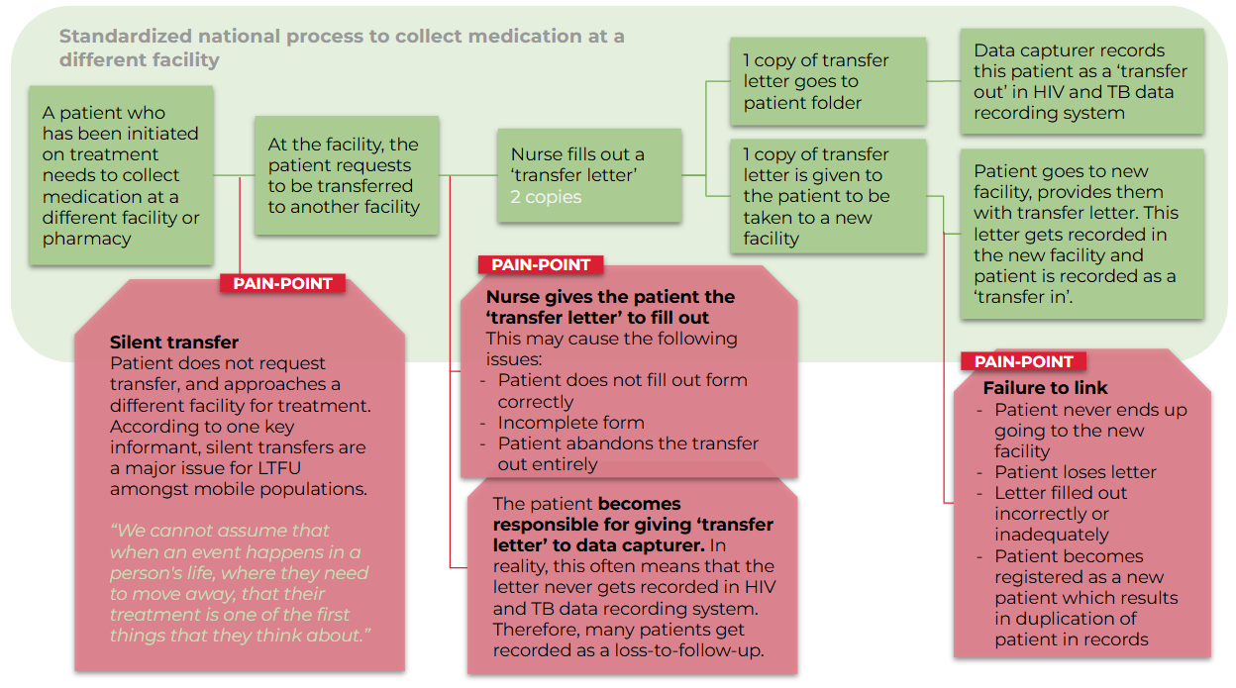

Figure 6: Standard transfer out process from facilities and pain points within this process

Appendix 3 | Detailed secondary data analysis
Monitoring temporary mobility in South Africa presents inherent challenges due to its fluid and frequently informal character. A comprehensive understanding therefore requires the integration of estimates from diverse data sources to form a well-rounded picture. This section compiles estimates of both internal and cross-border temporary mobility, sourcing data from various secondary resources such as the DHS, IOM data, Agincourt HDSS, and NIDS. These sources provide insightful perspectives on the scale and patterns of mobility within South Africa.

Internal mobility

Demographic Health Survey, South Africa 2016
The DHS 2016 survey conducted in South Africa provides valuable insights into mobility patterns across all individuals residing in South Africa. Respondents were asked about the frequency and duration of their absences from home in the past 12 months. The data, summarized in Figure 7, reveals that at least 15% of the population exhibited substantial mobility, leaving home either 12 times or more during the year or leaving home at least once for a period of one month or more. This mobility varied across age groups, with the highest prevalence observed among men aged 35-39. While the data predates the COVID-19 pandemic, it offers a crucial baseline for understanding temporary mobility trends and their potential implications for healthcare access and adherence. This data can be used as a baseline figure where other, more recent, or specific data does not exist.

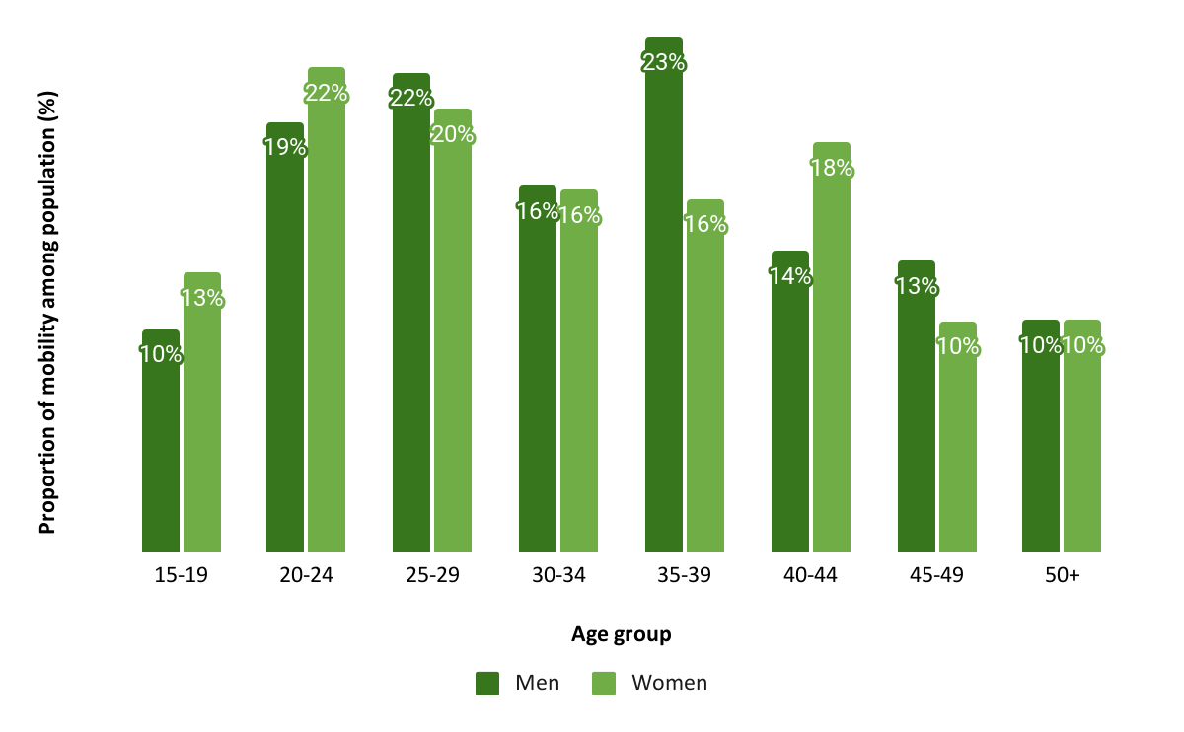

Figure 7: Extent of mobility derived from DHS 2016 survey in South Africa

Other health and demographic surveillance system data
There are several important longitudinal studies which investigate internal temporary migration dynamics in South Africa. These are summarized below:
- Collinson and Ginsburg's 2023 study examines South Africa's internal migration dynamics, drawing on longitudinal data from two key sources: The South African Population Research Infrastructure Network (SAPRIN) and the Agincourt Migrant Health Follow-up Study (MHFUS). These resources provide an empirical basis for interpreting national census data patterns. The study's key findings outline specific migration trends. Temporary migration peaks at age 22, with rates of 15% for males and 12% for females, while a considerable part of the population, particularly women aged 18-35, tend towards permanent migration. Together, these findings underscore the complexity and nuances of internal migration patterns in South Africa.

- Another study by Muhwava et al. (2010) delved into migration levels, trends, and patterns in rural KwaZulu-Natal, South Africa. This investigation used data from the Africa Center Demographic Information System from 2001 to 2007. Remarkably, the study found that at any given time, about a third of household members were non-resident; where non-resident is defined as an individual who fulfills the usual criteria for membership but who, specifically, does not fulfill conditions for residency, i.e. a member who normally lives (or spends most nights) outside the Demographic Surveillance Area’. More precisely, 31% of females and 37% of males were non-residents. However, the generalizability of this research is somewhat limited, as it specifically pertains to this rural area.

- An additional investigation by Nardell et al. (2024) analyzed 150 adult mobile men (≥18 years) in Johannesburg between October and November 2020. Participants were sampled from five sites often frequented by migrants for work, shelter, transit, or leisure. Findings indicated that 40% of participants were internal migrants, i.e., South African men born outside Gauteng Province, while 22% were international migrants, i.e., men born outside South Africa. It was also highlighted that individuals without permanent residency or citizenship were over twice as likely to report "never visiting a health facility," compared to citizens or permanent residents (28.6% vs. 10.6%). The study underscored a high proportion of migrants among the sampled men in Johannesburg and the need for HIV and other healthcare services that effectively reach this group.
Due to the limited generalizability and varying definitions, we did not make use of the data obtained from the HDSS sites and other smaller studies.

The National Income Dynamics Study (NIDS) Dataset
The National Income Dynamics Study (NIDS), available through the DataFirst portal, offered us a nationally representative panel dataset of South African households. Prior studies utilized waves 1 and 2 of the NIDS dataset to estimate the count of migrants relocating between 2008 (wave 1) and 2010 (wave 2), retrospective migrants moving between 2003 and 2008, and labor migrants absent for employment in 2008, with the aim of illuminating short-term internal mobility patterns. Our examination of waves 4 (2014-2015) and 5 (2017) granted us valuable household residence definitions and an overview of the surveyed population's movement or stability between the waves. However, the data lacked granularity regarding movers' (between wave 4 and 5) permanence and direction of movement, thereby offering insufficient detail on the nature and extent of temporary mobility within and across South Africa.
A panel dataset from waves 4 and 5 of NIDS uncovers essential demographic and mobility patterns across 10-year age bands of South Africa's adult population, as illustrated in Figure 8 below. These estimates are weighted to ensure their national representativeness.
The youngest age group (15-24) demonstrates the most significant mobility, with nearly 1.5 million labeled as "movers." Considerable mobility is also apparent among the 25-34 and 35-44 age bands, with around 2.9 million and 1.9 million movers, respectively. However, mobility shrinks with age, dropping to roughly 89,000 movers in the 75-84 age group and about 5,000 among those aged 85 and above.
Overall, the data reveals a trend of high mobility among young adults, gradually declining with age. This suggests a typical demographic pattern where younger South Africans are considerably more mobile than their older counterparts, likely driven by life-stage transitions such as education pursuit, job seeking, or exploring other opportunities.
While this data aids in understanding migration trends, the variables' definitions pertain mainly to permanent migrations rather than temporary ones. Therefore, we did not utilize these estimates in our ecological analysis.
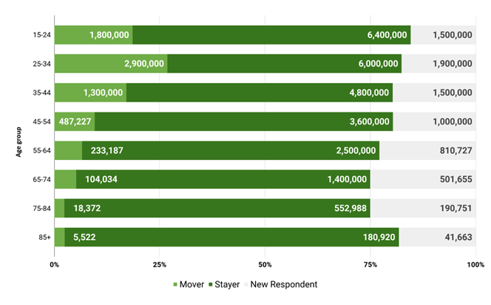

Figure 8: Migration between waves 4 (2014 - 2015) and 5 (2017) by 10-year age bands

Hall et al.'s (2015) review of wave 1 (2008) and wave 3 (2012) of the National Income Dynamics Study (NIDS) sheds light on the mobility and migration trends of South African youth. Predominantly, movers tend to be younger and better-educated compared to non-movers. The mobility rates differ by race, with 37% of White youth, 20% of African youth, and 12% of Colored youth showing movement, and a substantial 85% of those who moved during this period being African youth. While the directional flow patterns in Figure 9 below indicate a substantial amount of urban-to-urban movement (50%), the data also highlights a significant amount of rural-to-urban migration, accounting for 25% of all movements. This rural-to-urban migration is particularly noteworthy considering the higher costs typically associated with such moves. An additional 20% of the movements were rural-to-rural.
Hall et al.'s (2015) analysis also establishes distinct migration motives among males and females aged 15-34, with work opportunities being the primary driver for males (73%) and a significant factor for females (50%), who also migrated for educational purposes (22%). The prominence of urban-to-urban and rural-to-urban movements underscores the significance of temporary mobility in the quest for economic opportunities and education. This trend not only shapes the socio-economic dynamics of urban centers but also impacts the livelihoods and health outcomes in rural areas.
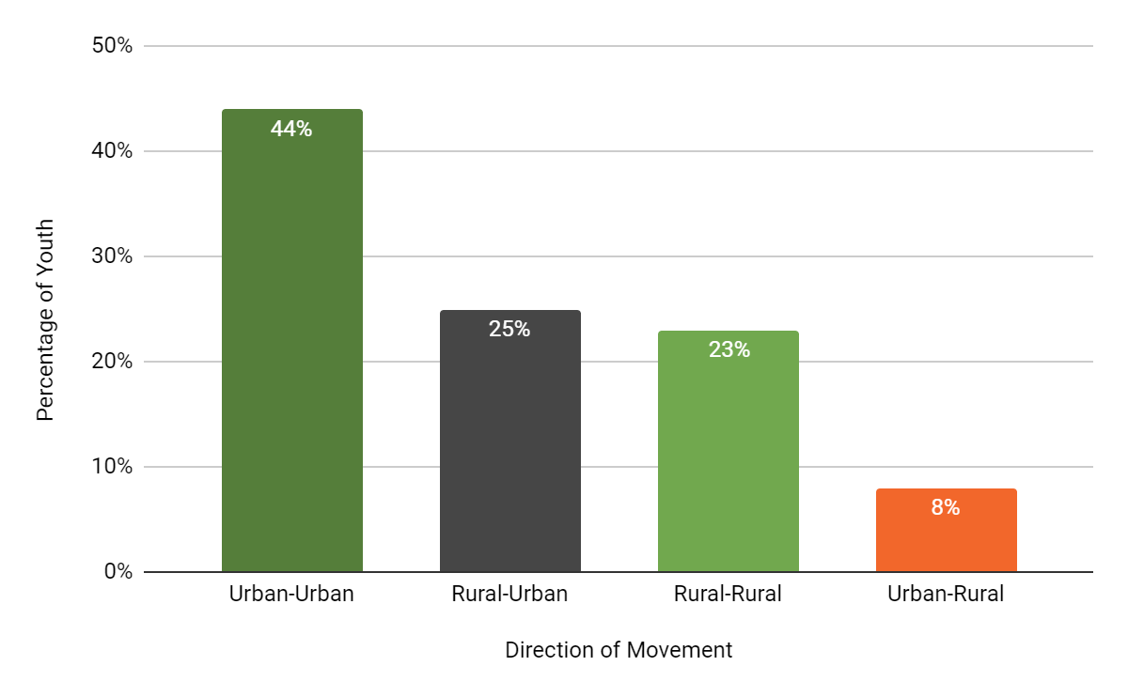

Figure 9: Directional movement of youth amongst urban and rural regions

South Africa’s Population Census Data
Insights into permanent migration trends are crucial for understanding wider mobility patterns, including temporary and circular migration. Intercensal migration flows between the 2011 and 2022 South African censuses disclose differing mobility patterns across provinces. Western Cape, Northern Cape, North West, Gauteng, and Mpumalanga all registered positive net-migration, indicating these provinces attracted more migrants than they lost. In contrast, Limpopo and Eastern Cape exhibited significant negative net-migration.
Regarding in-migration percentages, Gauteng and Western Cape emerged as the provinces attracting the highest volume of migrants between the two censuses, as illustrated in Figure 10 below. Northern Cape, however, presented the lowest share of period migrants at 2.6%. Notably, Eastern Cape demonstrated a substantial increase of 5 percentage points in in-migration, rising from 5.3% in 2011 to 10.3% in 2022.

2011 | 2022
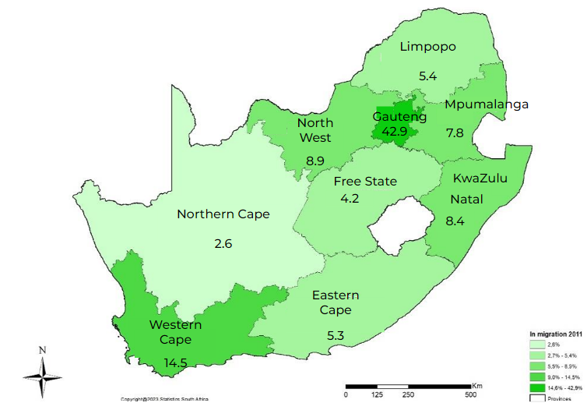 | 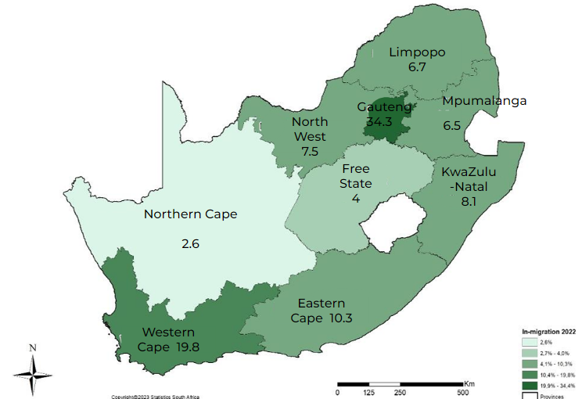

Figure 10: Percentage distribution of period in-migration by province, 2011 and 2022¹⁷

Out-migration trends illustrate that Gauteng, Eastern Cape, Limpopo, and KwaZulu-Natal consistently exhibited a high proportion of out-migration in both censuses, as depicted in Figure 11 below. Significantly, Gauteng's share of out-migration escalated from 17.8% in 2011 to 26.7% in 2022. Conversely, the Northern Cape had the smallest share of out-migration, registering 3.0% in 2011 and declining to 2.2% in 2022.
2011 | 2022
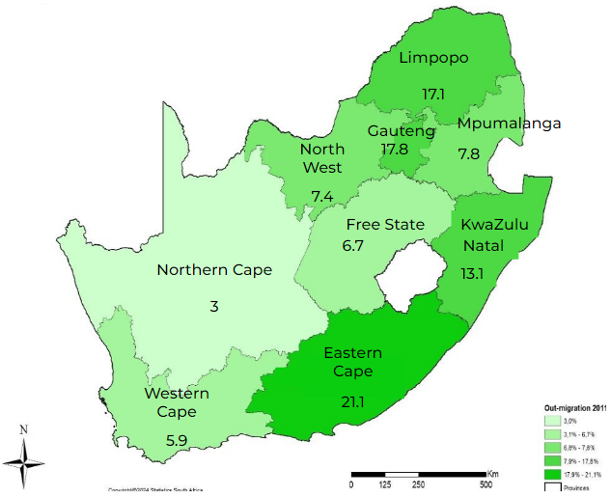 | 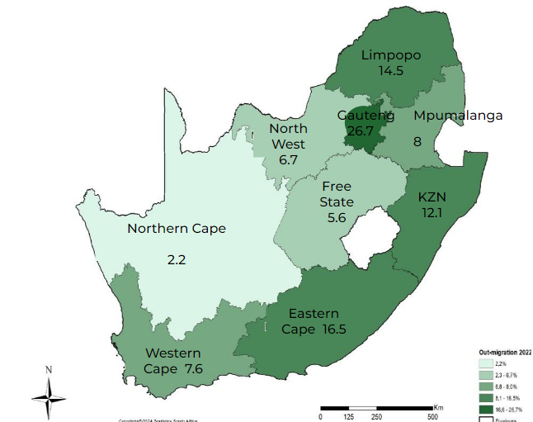

Figure 11: Percentage distribution of period out-migration by province, 2011 and 2022¹⁷
A vast bulk of mobility research concentrates on migration, typically defined by permanent or semi-permanent changes in residence. For a more detailed understanding of mobility, researchers are now leveraging alternative data sources like cell phone records. Case in point, a study in Rwanda found that 32% of cell phone owners lived away from their home district for three to twelve-month periods between 2005 and 2008. In Kenya and Namibia, respective daily district border crossings by 5% and 13% of cell phone users were recorded. These patterns of temporary mobility potentially hold equal, if not superior, influence on HIV care outcomes compared to permanent migration, thereby highlighting the importance of this oft-neglected aspect of cross-border mobility.

Cross-border mobility

IOM Flow Monitoring Data
The 2023 IOM Flow Monitoring data, depicted in Figure 12 below, reveals detailed patterns of short-term mobility (less than 6 months) across primary and secondary corridors from the Southern African Development Community (SADC) to South Africa. The data shows that 27% of all cross-border transfers are short-term. The primary corridors, Beitbridge and Ressano Garcia, demonstrate 41.5% and 17.2% short-term mobility, respectively. Furthermore, there is a general trend of greater short-term movements from South Africa to neighboring countries, resulting in asymmetric flows. A summary of the IOM Flow Monitoring data is presented in the table below.
While these patterns underscore significant short-term mobility, they exist within a broader context of cross-border labor migration and traditional mobility research. These short-term movements primarily encompass activities such as short-term trade, seasonal work, social visits, and business travel. They operate concurrently with longer-term labor migration patterns, particularly through corridors like Beitbridge and Ressano Garcia.

Table 12: Directional flows for monthly and short-term migration across key corridors in Southern Africa
 | Corridor | Direction | Average Monthly Flow | Short-term Mobility Average Monthly Flow | Average Annual Flow | Short-term Mobility Average Annual Flow | Short-term Annual Flow as % of Average Annual Flow
 | Zimbabwe – South Africa (Beitbridge) | Zimbabwe to South Africa | 7957 | 1344 | 238720 | 40308 | 16.90%
 | Zimbabwe – South Africa (Beitbridge) | South Africa to Zimbabwe | 13263 | 4554 | 397880 | 136634 | 34.30%
 | Mozambique (Ressano Garcia) – South Africa | Mozambique to South Africa | 1191 | 191 | 35720 | 5737 | 16.10%
 | Mozambique (Ressano Garcia) – South Africa | South Africa to Mozambique | 612 | 31 | 18360 | 936 | 5.10%
 | Zimbabwe (Mutare) – Mozambique (Manica) | South Africa to Elsewhere | 10 | 4 | 306 | 109 | 35.70%
 | Zimbabwe (Mutare) – Mozambique (Manica) | Elsewhere to South Africa | 21 | 7 | 622 | 222 | 35.60%
 | Zimbabwe (Chirundu) – Zambia | South Africa to Elsewhere | 56 | 14 | 1691 | 429 | 25.40%
 | Zimbabwe (Chirundu) – Zambia | Elsewhere to South Africa | 46 | 25 | 1366 | 758 | 55.50%
 | Zimbabwe – Botswana (Plumtree) | South Africa to Elsewhere | 93 | 22 | 2786 | 666 | 23.90%
 | Zimbabwe – Botswana (Plumtree) | Elsewhere to South Africa | 49 | 16 | 1478 | 483 | 32.70%
 | Malawi (Mwanza) – Mozambique (Zobue) | South Africa to Elsewhere | 447 | 212 | 13415 | 6358 | 47.40%
 | Malawi (Mwanza) – Mozambique (Zobue) | Elsewhere to South Africa | 416 | 164 | 12473 | 4930 | 39.50%
 | Total |  | 24,161 | 6,586 | 724,817 | 197,572 | 27.0%

Appendix 4 | Definitions of mobility

Table 13: Ways that different organizations define mobility
Organization | Term | Definition
Agincourt | Temporary migrant | A household member who is away the majority of time, but retains a significant link. This implies that the person is a de jure member of the household, but absent for more than six months of a year.¹⁶
International Organization for Migration | Internal migrant | Any person who is moving or has moved within a State for the purpose of establishing a new temporary or permanent residence or because of displacement (IOM, 2019b).
International Organization for Migration | Internal migration | The movement of people within a State involving the establishment of a new temporary or permanent residence
International Organization for Migration | Internal temporary mobility | Refers to all movements within a country that does not result in a change of place of residence
International Organization for Migration | International mobility | All movements that cross international borders within a given year (UN Expert Group on Migration Statistics).
International Organization for Migration | International temporary mobility | Refers to all movements that cross international borders that do not result in a change in the country of residence
International Organization for Migration | Labor migration | Movement of persons from one State to another, or within their own country of residence, for the purpose of employment
International Organization for Migration | Labor mobility | labor mobility – or mobility of workers – can be either occupational (movement along the occupational ladder) or geographic (movement across geographic locations). In the context of migration, geographic labor mobility is implied
International Organization for Migration | Migrant worker | A person who is to be engaged, is engaged or has been engaged in a remunerated activity in a State of which he or she is not a national
Statistics South Africa | Circular migration | A migration is circular when the usual place of residence (de jure) remains in the rural or peri-urban setting, but a person migrates usually for employment or education purposes, and stays connected to the ‘sending’ household through communication, regular return visits and with a high likelihood of cash or non-monetary remittances.
Statistics South Africa | Environmental migration | The movement of persons or groups of persons who, predominantly for reasons of sudden or progressive changes in the environment that adversely affect their lives or living conditions, are forced to leave their places of habitual residence, or choose to do so, either temporarily or permanently, and who move within or outside their country of origin or habitual residence (IOM, 2019b).
Statistics South Africa | Internal migrant | Definition referenced is from the IOM definition above
Statistics South Africa | Migrant | An umbrella term, not defined under international law, reflecting the common lay understanding of a person who moves away from his or her place of usual residence, whether within a country or across an international border, temporarily or permanently, and for a variety of reasons. The term includes a number of well-defined legal categories of people, such as migrant workers; persons whose particular types of movements are legally defined, such as smuggled migrants; as well as those whose status or means of movement are not specifically defined under international law, such as international students (IOM, 2019b).
Statistics South Africa | Migrant in an irregular situation | A person who moves or has moved across an international border and is not authorized to enter or to stay in a State pursuant to the law of that State and to international agreements to which that State is a party (IOM, 2019b).
National Income Dynamics Survey | Migrant or spatial mover | Variable name, w2_mover: a NIDS panel member is a ‘mover’ if that individual resides in W2 at a location more than 100 m from their original location in W1 (SALDRU, 2012). Or they are no longer in their original location and survey teams were unable to track these individuals.
National Income Dynamics Survey | Migrants (Moved 2008-2010) | Resident household members who were observed moving between 2008 and 2010. These individuals have full questionnaires in 2008 - W1 (prior to relocating). In 2010 - W2, many of these individuals were not tracked and therefore lost due to attrition (possibly temporary). The sample of migrants likely suffers from selection bias in W2. Identified in their household of origin in 2008 prior to relocation.
National Income Dynamics Survey | Retrospective Migrants (moved 2003 - 2008) | Resident household members who answered in the affirmative to a question asking whether they had moved in the last 5 years (prior to 2008). These individuals have full questionnaires. Identified in their household of destination in 2008 after relocation prior to 2008.
National Income Dynamics Survey | labor Migrants (Absent for Employment: 2008) | Non-resident household members in 2008. Individuals who are absent from the household for a month or more for employment or to look for employment. These individuals do not have full questionnaires and are not tracked over time. Identified in their household of origin in 2008.
National Income Dynamics Survey | Household Resident | Residency in NIDS is defined by presence in the household for at least four nights per week. In keeping with the complexity of living arrangements in South Africa, household membership is defined to include individuals spending more than 15 days per year at the household and sharing food and resources (SALDRU, 2012).
World Health Organization | Labor mobility | Temporary or short-term movements of persons for employment-related purposes
Demographic Health Survey 2016 | Temporary mobility | The DHS survey captures data on temporary mobility which does not involve a change in address using two questions:  - How many times have you left home for one night or more in the last year?  - Have you spent more than one month away from home in the last 12 months?  We defined individuals as “mobile” if they left home 12 times or more, or were away for a month or more in the last year.
United Nations Economic Commission for Europe | Circular labo(u)r migration | Movement wherein poor people from low productivity areas migrate for part of the year, often on a seasonal basis, to areas with more job opportunities and wages. It is considered to be a contract of mutual cooperation and insurance between sending families and the migrants themselves.

This work is funded by the Gates Foundation, with reference number INV-058247, under the project name: Short-Term Technical Assistance for TB and HIV Interventions
We acknowledge that UNAIDS estimates that there are 7.7 million PLHIV in South Africa, however, we have used our own estimate of 7.33 million for consistency.
This work is funded by the Gates Foundation, with reference number INV-058247, under the project name: Short-Term Technical Assistance for TB and HIV Interventions
An exploratory objective was originally included to explore plausible data approaches for quantifying the number of PLHIV or individuals with TB who develop negative treatment outcomes (because of their mobility). At present, we could not identify any other existing data sources which could be used to extrapolate the proportion of negative TB and HIV outcomes which could be attributed to mobility, or vice versa, even through an ecological analysis.
Internal mobility is often referred to as circular migration or temporary internal mobility in the literature.
Cross border mobility if often referred to as “temporary migration” in the literature.
BMJ Journals. Sexually Transmitted Infections Data. (2024). https://sti.bmj.com/
Department of Higher Education and Training. Statistics on Post-School Education and Training in South Africa: 2019. (2019). https://www.dhet.gov.za/DHET%20Statistics%20Publication/Statistics%20on%20Post-School%20Education%20and%20Training%20in%20South%20Africa%202019.pdf
We note that other mobile population groups may exist, namely refugees, internally displaced people, and individuals travelling to seek out health care. The former groups have not been included in this analysis as this falls under permanent migration, while the latter group has been excluded due to a scarcity of data on the topic.
For the upper and lower bounds, the percentages used are calculated as: nr*(90%/100%) and nr*(27%/100%), respectively as 100% of cross-border truck drivers are assumed to be mobile for the upper bound calculation.
For the median and lower bounds, the percentages used are calculated as: nr*(67%/50%) and nr*(27%/50%), respectively as 50% of cross-border hospitality workers are assumed to be mobile for the upper bound calculation. This percentage is based on the assumption that hospitality workers are likely to earn higher wages, and thus can afford to move their entire family to their working location.
These estimates are based on the median bound (67%).
This considers economic opportunity-related mobility, students and undocumented individuals only, and is excluding the general population sub-total.
These estimates are based on the median bound (67%).
These estimates are based on the median bound (67%).
These estimates are based on the median bound (67%).
This intervention, while helpful, is unlikely to be approved due to data access issues, and parallels with the centralized electronic medical record system currently being developed.
National Department of Health(NDOH), Statistics South Africa (Stats SA), South African Medical Research Council (SAMRC), & ICF. South African Demographic and Health Survey Fey Findings. (2018).
The DHS Program. DHS Model Questionnaire - Phase 7 (English, French). https://dhsprogram.com/publications/publication-dhsq7-dhs-questionnaires-and-manuals.cfm (2015).
﷟HYPERLINK "https://www.zotero.org/google-docs/?87cKkG"Collinson, M. South Africa - Migrant Health Follow-Up Study Wave 01 (MHFUS). Agincourt Data Portal https://data.agincourt.co.za/index.php/catalog/395 (2023).
Muhwava, W. et al. Levels and Determinants of Population Migration in Rural KwaZulu-Natal, South Africa. (2023) https://researchonline.lshtm.ac.uk/id/eprint/2576242/1/302-417-1-PB.pdf
Nardell, M. F. et al. Migrant men and HIV care engagement in Johannesburg, South Africa. BMC Public Health 24, 435 (2024).
Collinson, M. South Africa - Migrant Health Follow-Up Study Wave 01 (MHFUS). Agincourt Data Portal https://data.agincourt.co.za/index.php/catalog/395 (2023).
South African National Department of Health. National Consolidated Guidelines. (2020).
De Lannoy, A., Swartz, S., Lake, L. & Smith, C. Parenting Poverty and young People in South Africa: What are the connections. (2015).
Movement in this study is defined as movement within South Africa from one household to another that is: within a 5 kilometer radius; over 100 kilometers away; or over 500 kilometers away from the origin household.
Statistics South Africa. Migration Profile Report for South Africa: A Country Profile 2023. https://www.statssa.gov.za/publications/03-09-17/03-09-172023.pdf (2024).
International Organization for Migration. Southern Africa | Displacement Tracking Matrix. DTM Southern Africa https://dtm.iom.int/regions/southern-african.
Collinson, M. South Africa - Migrant Health Follow-Up Study Wave 01 (MHFUS). Agincourt Data Portal https://data.agincourt.co.za/index.php/catalog/395 (2023).
International Organization for Migration. Southern Africa | Displacement Tracking Matrix. DTM Southern Africa https://dtm.iom.int/regions/southern-african.
National Department of Health(NDOH), Statistics South Africa (Stats SA), South African Medical Research Council (SAMRC), & ICF. South African Demographic and Health Survey Fey Findings. (2018).
Clarke, R. & Eyal, K. Microeconomic determinants of spatial mobility in post-apartheid South Africa: Longitudinal evidence from the National Income Dynamics Study. Dev. South. Afr. 31, 168–194 (2014).
World Health Organization. The Internationally Platform on Health Worker Mobility. (2017). https://www.who.int/publications/m/item/the-international-platform-onhealth-worker-mobility
National Department of Health(NDOH), Statistics South Africa (Stats SA), South African Medical Research Council (SAMRC), & ICF. South African Demographic and Health Survey Fey Findings. (2018).

